Critical Thinking Group 4 : DATA621 Final Project

Table of Contents

TEAM MEMBERS: 2

OVERVIEW 2

DELIVERABLES 3

DATA EXPLORATION 3

Yearly Average Price For The Stocks: 6

Monthly Average Price For The Stocks 6

Average Price For A Stock From 2015 To 2020: 6

Avg Price By Sector: 7

Sector Per Year: 8

DATA PREPARATION 13

Analyzing Top 3 Stocks In Each Sector: 13

Build Data 16

Creating Time Series Object 16

Time Series Forecasting 21

Data From Apr 2015 To 2020 21

Current Year Data 27

Data Till Dec 2019 29

White Noise & Autoplots 31

Autocorrelation Of Time Series 36

BUILDING MODEL 41

Fitting Data 41

Fit With Only Data After 2020: 43

Fit With Data Before 2020 45

Predicting Time Series data 45

Using Full Data 46

Using Data Fit Till Dec 2019 48

Check Model 50

Compare The Model: 51

CONCLUSIONS 51

APPENDIX: 51

THANK YOU 52

# TEAM MEMBERS:

Rajwant Mishra  
Priya Shaji  
Debabrata Kabiraj  
Isabel Ramesar  
Sin Ying Wong  
Fan Xu

-------------------------------------------------

# OVERVIEW

In this analysis we will analyze Stocks data and check and how Covid-19 had impacted it from the beginning of the year 2020. We have collected data from exchange for last Five year starting from year 2015 to Apr 27, 2020. We would be using Moving Average Model and Auto Regressive model to analyze the time series data.

|  |  |  |  |
| --- | --- | --- | --- |
| Column Name | Type | Sample Data | Descrption |
| X1 | num | 0 | Sequence |
| begins_at | POSIXct, | 4/28/2015 | Date |
| open_price | num | 24.9 | Open Price |
| close_price | num | 24.9 | Close Price |
| high_price | num | 24.9 | High Price of stock on the given date. |
| low_price | num | 24.9 | Loweest price of the stock on the given date |
| volume | num | 0 | Volume of the shares trade on the give date |
| session | chr | reg | Type of the data session Regular /Extended |
| interpolated: | TRUE | TRUE | Not used |
| sname | chr | AA | Stock Name |

Below is a short snippet of the data in the data set:  
 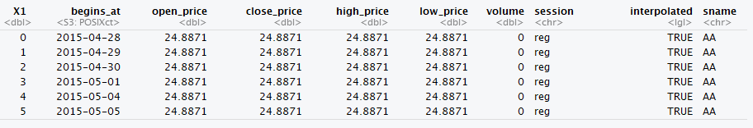

Sector information for the stocks:

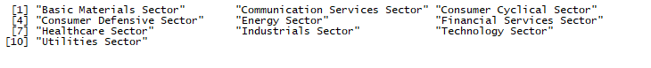

# DELIVERABLES

* A write-up submitted in PDF format. Your write-up should have four sections. Each one is described below. You may assume you are addressing me as a fellow data scientist, so do not need to shy away from technical details.
* Assigned predictions (the number of wins for the team) for the evaluation data set.
* Include your R statistical programming code in an Appendix.

# DATA EXPLORATION

We will be exploring the 500 stocks data by sectors and then we will choose one stocks to fo further analysis.

We have collected all the stocks from NYSE and corresponding sector info:

|  |  |  |  |  |
| --- | --- | --- | --- | --- |
| Basic Materials Sector |  |  |  |  |
| Communication Services Sector |  |  |  |  |
| Consumer Cyclical Sector |  |  |  |  |
| Consumer Defensive Sector |  |  |  |  |
| Energy Sector |  |  |  |  |
| Financial Services Sector |  |  |  |  |
| Healthcare Sector |  |  |  |  |
| Industrials Sector |  |  |  |  |
| Technology Sector |  |  |  |  |
| Utilities Sector |  |  |  |  |

Let’s looks at our data structure of the data :

Observations: 370,440

Variables: 10

$ X1 *<dbl>* 0, 1, 2, 3, 4, 5, 6, 7, 8, 9, 10, 11, 12, 13, 14, 15, 16, 17,...

$ begins_at *<dttm>* 2015-04-28, 2015-04-29, 2015-04-30, 2015-05-01, 2015-05-04, ...

$ open_price *<dbl>* 24.8871, 24.8871, 24.8871, 24.8871, 24.8871, 24.8871, 24.8871...

$ close_price *<dbl>* 24.8871, 24.8871, 24.8871, 24.8871, 24.8871, 24.8871, 24.8871...

$ high_price *<dbl>* 24.8871, 24.8871, 24.8871, 24.8871, 24.8871, 24.8871, 24.8871...

$ low_price *<dbl>* 24.8871, 24.8871, 24.8871, 24.8871, 24.8871, 24.8871, 24.8871...

$ volume *<dbl>* 0, 0, 0, 0, 0, 0, 0, 0, 0, 0, 0, 0, 0, 0, 0, 0, 0, 0, 0, 0, 0...

$ session *<chr>* "reg", "reg", "reg", "reg", "reg", "reg", "reg", "reg", "reg"...

$ interpolated *<lgl>* TRUE, TRUE, TRUE, TRUE, TRUE, TRUE, TRUE, TRUE, TRUE, TRUE, T...

$ sname *<chr>* "AA", "AA", "AA", "AA", "AA", "AA", "AA", "AA", "AA", "AA", "...

Summary of the data:

## X1 begins_at open_price

## Min. : 0.0 Min. :2015-04-28 00:00:00 Min. : 0.00

## 1st Qu.: 314.8 1st Qu.:2016-07-26 18:00:00 1st Qu.: 13.61

## Median : 629.5 Median :2017-10-24 12:00:00 Median : 26.33

## Mean : 629.5 Mean :2017-10-25 14:51:25 Mean : 48.92

## 3rd Qu.: 944.2 3rd Qu.:2019-01-25 18:00:00 3rd Qu.: 56.09

## Max. :1259.0 Max. :2020-04-27 00:00:00 Max. :1266.56

## close_price high_price low_price volume

## Min. : 0.0052 Min. : 0.00 Min. : 0.0 Min. : 0

## 1st Qu.: 13.6100 1st Qu.: 13.72 1st Qu.: 13.5 1st Qu.: 103282

## Median : 26.3300 Median : 26.67 Median : 26.0 Median : 421838

## Mean : 48.9221 Mean : 49.43 Mean : 48.4 Mean : 1650980

## 3rd Qu.: 56.1200 3rd Qu.: 56.68 3rd Qu.: 55.5 3rd Qu.: 1332573

## Max. :1250.0000 Max. :1274.41 Max. :1232.0 Max. :375088650

## session interpolated sname

## Length:370440 Mode :logical Length:370440

## Class :character FALSE:362193 Class :character

## Mode :character TRUE :8247 Mode :character

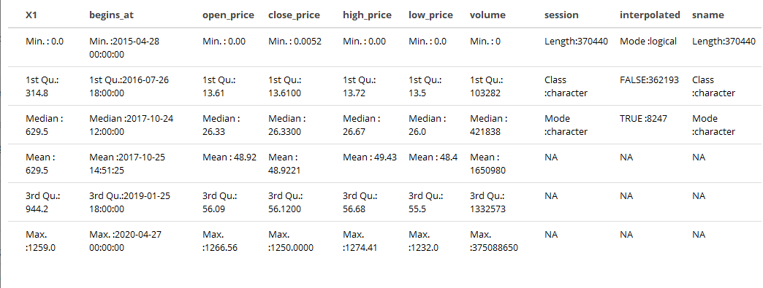

Calculate number of ZERO's in each variable in the main dataset:

| **variable** | **n** | **percent** |
| --- | --- | --- |
| volume | 8625 | 2.3% |
| X1 | 294 | 0.1% |
| high_price | 1 | 0% |
| low_price | 1 | 0% |
| open_price | 1 | 0% |

This clear from the above stats that in 2.3% of the data points we don’t have Any value, Zero point 1% of the stock has no name which counts 294 in number, there is no zeros for the high price , low price, open price . We will not use volume in our analysis at this time so we will drop those data points latter.

Let’s see how many stocks from 500 stocks we are studying fall under which sectors:

Stocks by Sector:

| **Sector**  <chr> | **CODE**  <chr> | **NAME**  <chr> |
| --- | --- | --- |
| Basic Materials Sector | GPRE | Green Plains Inc |
| Basic Materials Sector | BCPC | Balchem Corporation |
| Basic Materials Sector | STLD | Steel Dynamics, Inc |
| Basic Materials Sector | METC | Ramaco Resources, Inc |
| Basic Materials Sector | ASH | Ashland Global Holdings Inc |
| Basic Materials Sector | TRX | Tanzanian Gold Corporation |

6 rows

### Yearly Average Price For The Stocks:

| **sname**  <chr> | **Avg_price**  <dbl> |
| --- | --- |
| AA | 30.50011 |
| AAN | 40.21981 |
| AAP | 146.20186 |
| AAT | 40.64534 |
| AB | 26.15712 |
| ABB | 21.47852 |

6 rows

### Monthly Average Price For The Stocks

| **sname**  <chr> | **Avg_price**  <dbl> |
| --- | --- |
| AA | 30.50011 |
| AAN | 40.21981 |
| AAP | 146.20186 |
| AAT | 40.64534 |
| AB | 26.15712 |
| ABB | 21.47852 |

### Average Price For A Stock From 2015 To 2020:

data_price_year[**which**(data_price_year**$**sname**==**'AA'),]

|  |
| --- |
|  |

| **Year**  <dbl> | **sname**  <chr> | **Avg_price**  <dbl> |
| --- | --- | --- |
| 2015 | AA | 24.88710 |
| 2016 | AA | 25.42091 |
| 2017 | AA | 38.25301 |
| 2018 | AA | 44.25964 |
| 2019 | AA | 23.70490 |
| 2020 | AA | 12.37538 |

6 rows

Now, let’s only target shares whose open prices are between 100 and 200:

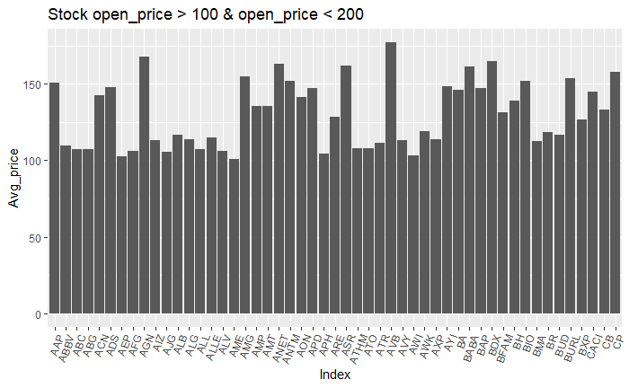

### Avg Price By Sector:

Checking only with 500 stocks data and analyze the distribution of data in each sector.

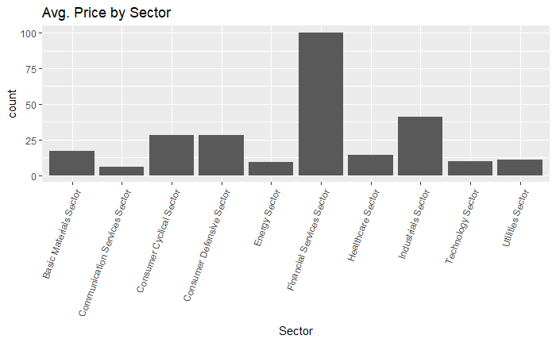

The graph above tells us about average price of stocks for each sector name.

### Sector Per Year:

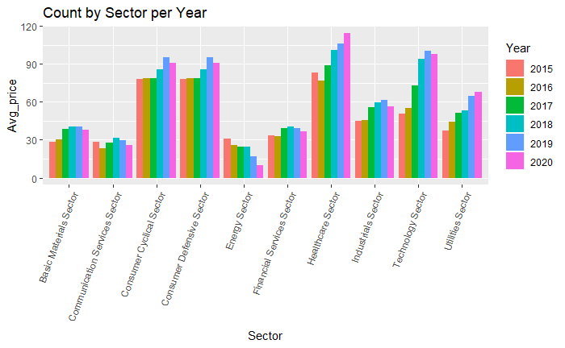

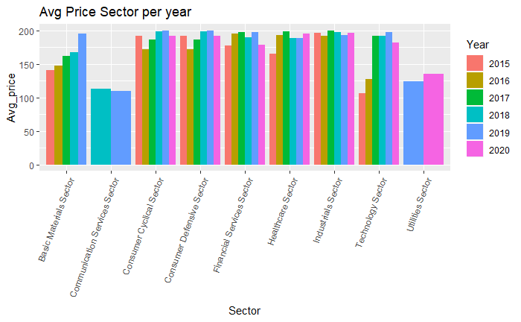

The graph above tells us about yearly increase avg. Price in each sectors.

Below is Graph of the sector by Month and year, which shows some pattern. We will do some analysis to see how stocks from few of these industries fit with `AR(Auto Regression)` and `MA(Moving Average)` model. Analyzing average price of stocks yearly for each sector in the dataset.

Analyzing average price of stocks monthly for each sector in the dataset:

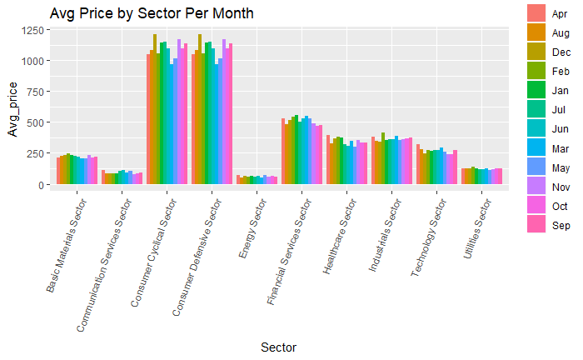

Box plot for year:

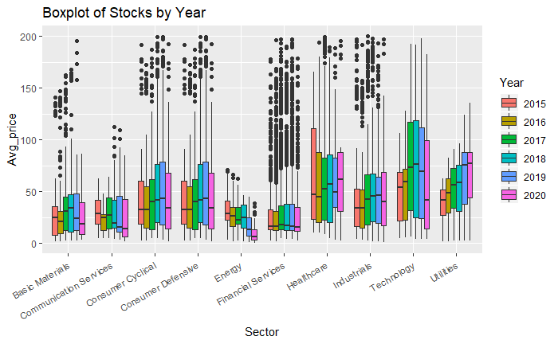

From the box plot above we can analyze that mostly all the sectors in our dataset have some outliers throughout 5 years, except two sectors that are: `Technology` and `Utilities`.

# DATA PREPARATION

### Analyzing Top 3 Stocks In Each Sector:

| **sname**  <chr> | **Avg**  <dbl> | **Sector**  <chr> | **NAME**  <chr> |
| --- | --- | --- | --- |
| AZO | 800.9067 | Consumer Cyclical Sector | AutoZone, Inc |
| AZO | 800.9067 | Consumer Defensive Sector | AutoZone, Inc |
| BLK | 419.6630 | Financial Services Sector | BlackRock, Inc |
| BH | 291.6055 | Consumer Cyclical Sector | Biglari Holdings Inc |
| BH | 291.6055 | Consumer Defensive Sector | Biglari Holdings Inc |
| BA | 245.1263 | Industrials Sector | The Boeing Company |
| BIO | 233.8155 | Healthcare Sector | Bio-Rad Laboratories, Inc |
| AGN | 211.6256 | Healthcare Sector | Allergan plc |
| ADS | 208.0295 | Financial Services Sector | Alliance Data Systems Corporation |
| ANTM | 206.0807 | Healthcare Sector | Anthem, Inc |
| BDX | 203.2816 | Healthcare Sector | Becton, Dickinson and Company |
| BAP | 181.8395 | Financial Services Sector | Credicorp Ltd |
| CP | 178.9086 | Industrials Sector | Canadian Pacific Railway Limited |
| AYI | 171.8084 | Industrials Sector | Acuity Brands, Inc |
| ANET | 169.3343 | Technology Sector | Arista Networks, Inc |
| ASR | 163.6174 | Industrials Sector | Grupo Aeroportuario del Sureste, S. A. B. de C. V |

Building main stock data table to be used for analysis;

| **sname**  <chr> | **Avg**  <dbl> | **Sector**  <chr> | **NAME**  <chr> |
| --- | --- | --- | --- |
| AZO | 800.9067 | Consumer Cyclical Sector | AutoZone, Inc |
| AZO | 800.9067 | Consumer Defensive Sector | AutoZone, Inc |
| BLK | 419.6630 | Financial Services Sector | BlackRock, Inc |
| BH | 291.6055 | Consumer Cyclical Sector | Biglari Holdings Inc |
| BH | 291.6055 | Consumer Defensive Sector | Biglari Holdings Inc |
| BA | 245.1263 | Industrials Sector | The Boeing Company |

Building main stock data table to be used for analysis;

| **sname**  <chr> | **Avg**  <dbl> | **Sector**  <chr> | **NAME**  <chr> |
| --- | --- | --- | --- |
| AZO | 800.9067 | Consumer Cyclical Sector | AutoZone, Inc |
| AZO | 800.9067 | Consumer Defensive Sector | AutoZone, Inc |
| BLK | 419.6630 | Financial Services Sector | BlackRock, Inc |
| BH | 291.6055 | Consumer Cyclical Sector | Biglari Holdings Inc |
| BH | 291.6055 | Consumer Defensive Sector | Biglari Holdings Inc |
| BA | 245.1263 | Industrials Sector | The Boeing Company |

We will study the flow on some of the stocks from Health and Tech Sectors like:

ANTM Anthem, Inc

ANET Arista Networks, Inc

BA The Boeing Company

Glimpse of data:

Added Month name and converted data to yearly data so that further analysis can be done:

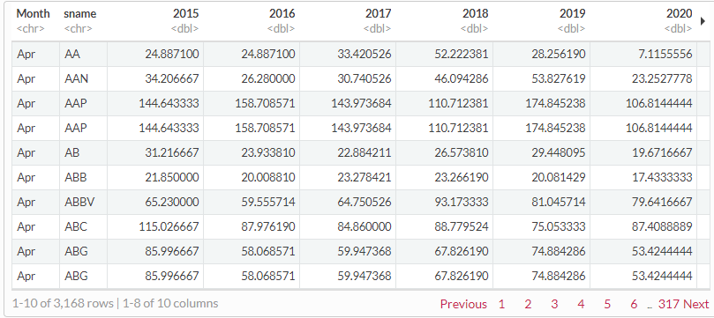

Summary of the working data :

## X1 begins_at open_price

## Min. : 0.0 Min. :2015-04-28 00:00:00 Min. : 0.00

## 1st Qu.: 314.8 1st Qu.:2016-07-26 18:00:00 1st Qu.: 13.61

## Median : 629.5 Median :2017-10-24 12:00:00 Median : 26.33

## Mean : 629.5 Mean :2017-10-25 14:51:25 Mean : 48.92

## 3rd Qu.: 944.2 3rd Qu.:2019-01-25 18:00:00 3rd Qu.: 56.09

## Max. :1259.0 Max. :2020-04-27 00:00:00 Max. :1266.56

## close_price high_price low_price volume

## Min. : 0.0052 Min. : 0.00 Min. : 0.0 Min. : 0

## 1st Qu.: 13.6100 1st Qu.: 13.72 1st Qu.: 13.5 1st Qu.: 103282

## Median : 26.3300 Median : 26.67 Median : 26.0 Median : 421838

## Mean : 48.9221 Mean : 49.43 Mean : 48.4 Mean : 1650980

## 3rd Qu.: 56.1200 3rd Qu.: 56.68 3rd Qu.: 55.5 3rd Qu.: 1332573

## Max. :1250.0000 Max. :1274.41 Max. :1232.0 Max. :375088650

## session interpolated sname

## Length:370440 Mode :logical Length:370440

## Class :character FALSE:362193 Class :character

## Mode :character TRUE :8247 Mode :character

##

*# Only Keeping Date, open_price , sname , interpolated = FALSE*

**glimpse**((data_pro))

## Observations: 370,440

## Variables: 10

## $ X1 <dbl> 0, 1, 2, 3, 4, 5, 6, 7, 8, 9, 10, 11, 12, 13, 14, 15, ...

## $ begins_at <dttm> 2015-04-28, 2015-04-29, 2015-04-30, 2015-05-01, 2015-...

## $ open_price <dbl> 24.8871, 24.8871, 24.8871, 24.8871, 24.8871, 24.8871, ...

## $ close_price <dbl> 24.8871, 24.8871, 24.8871, 24.8871, 24.8871, 24.8871, ...

## $ high_price <dbl> 24.8871, 24.8871, 24.8871, 24.8871, 24.8871, 24.8871, ...

## $ low_price <dbl> 24.8871, 24.8871, 24.8871, 24.8871, 24.8871, 24.8871, ...

## $ volume <dbl> 0, 0, 0, 0, 0, 0, 0, 0, 0, 0, 0, 0, 0, 0, 0, 0, 0, 0, ...

## $ session <chr> "reg", "reg", "reg", "reg", "reg", "reg", "reg", "reg"...

## $ interpolated <lgl> TRUE, TRUE, TRUE, TRUE, TRUE, TRUE, TRUE, TRUE, TRUE, ...

## $ sname <chr> "AA", "AA", "AA", "AA", "AA", "AA", "AA", "AA", "AA", ...

We will only be Keeping data which satisfies Date, open_price , sname (Name of stock) , interpolated = FALSE. Below is final data for further analysis .

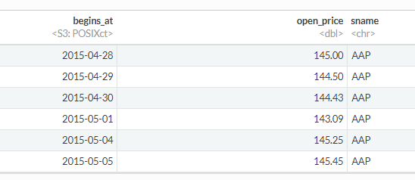

Converting the data of stocks in wide format:

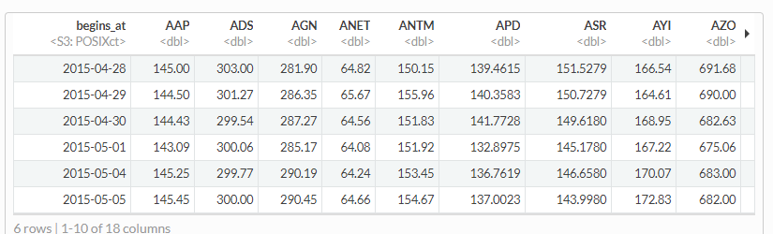

## Build Data

Fit an AR model to the following stocks, we would be using xts package in R to convert our data set to required time series data format.:

ANTM Anthem, Inc

ANET Arista Networks, Inc

BA The Boeing Company

### Creating Time Series Object

*# wide_data_Main$begins_at <- as_datetime(wide_data_Main$begins_at)*

stocks_ANTM <-**xts**(wide_data_Main**$**ANTM, order.by=**as.Date**(wide_data_Main**$**begins_at))

stocks_ANET <- **xts**(wide_data_Main**$**ANET, order.by=**as.Date**(wide_data_Main**$**begins_at))

stocks_BA <- **xts**(wide_data_Main**$**BA, order.by=**as.Date**(wide_data_Main**$**begins_at))

*# Data for only 2020 data*

wide_data_Main_20 <- wide_data_Main[**which**(**year**(wide_data_Main**$**begins_at) **%in%** **c**("2020")),]

*# Data for only Rest than 2020 data*

wide_data_Main_Old <- wide_data_Main[**-which**(**year**(wide_data_Main**$**begins_at) **%in%** **c**("2020")),]

stocks_ANTM_MY <-**xts**(wide_data_Main_20**$**ANTM, order.by=**as.Date**(wide_data_Main_20**$**begins_at))

stocks_ANET_MY <- **xts**(wide_data_Main_20**$**ANET, order.by=**as.Date**(wide_data_Main_20**$**begins_at))

stocks_BA_MY <- **xts**(wide_data_Main_20**$**BA, order.by=**as.Date**(wide_data_Main_20**$**begins_at))

stocks_ANTM_old <-**xts**(wide_data_Main_Old**$**ANTM, order.by=**as.Date**(wide_data_Main_Old**$**begins_at))

stocks_ANET_old <- **xts**(wide_data_Main_Old**$**ANET, order.by=**as.Date**(wide_data_Main_Old**$**begins_at))

stocks_BA_old <- **xts**(wide_data_Main_Old**$**BA, order.by=**as.Date**(wide_data_Main_Old**$**begins_at))

Checking the index of xts object:

**index**(stocks_ANTM_MY)

## [1] "2020-01-02" "2020-01-03" "2020-01-06" "2020-01-07" "2020-01-08"

## [6] "2020-01-09" "2020-01-10" "2020-01-13" "2020-01-14" "2020-01-15"

## [11] "2020-01-16" "2020-01-17" "2020-01-21" "2020-01-22" "2020-01-23"

## [16] "2020-01-24" "2020-01-27" "2020-01-28" "2020-01-29" "2020-01-30"

## [21] "2020-01-31" "2020-02-03" "2020-02-04" "2020-02-05" "2020-02-06"

## [26] "2020-02-07" "2020-02-10" "2020-02-11" "2020-02-12" "2020-02-13"

## [31] "2020-02-14" "2020-02-18" "2020-02-19" "2020-02-20" "2020-02-21"

## [36] "2020-02-24" "2020-02-25" "2020-02-26" "2020-02-27" "2020-02-28"

## [41] "2020-03-02" "2020-03-03" "2020-03-04" "2020-03-05" "2020-03-06"

## [46] "2020-03-09" "2020-03-10" "2020-03-11" "2020-03-12" "2020-03-13"

## [51] "2020-03-16" "2020-03-17" "2020-03-18" "2020-03-19" "2020-03-20"

## [56] "2020-03-23" "2020-03-24" "2020-03-25" "2020-03-26" "2020-03-27"

## [61] "2020-03-30" "2020-03-31" "2020-04-01" "2020-04-02" "2020-04-03"

## [66] "2020-04-06" "2020-04-07" "2020-04-08" "2020-04-09" "2020-04-13"

## [71] "2020-04-14" "2020-04-15" "2020-04-16" "2020-04-17" "2020-04-20"

## [76] "2020-04-21" "2020-04-22" "2020-04-23" "2020-04-24" "2020-04-27"

Checking the data of xts object:

**coredata**(stocks_ANTM_MY)

## [,1]

## [1,] 302.67

## [2,] 293.68

## [3,] 295.75

## [4,] 299.20

## [5,] 300.89

## [6,] 307.83

## [7,] 307.94

## [8,] 306.88

## [9,] 296.04

## [10,] 297.26

## [11,] 302.92

## [12,] 305.07

## [13,] 303.94

## [14,] 306.68

## [15,] 303.46

View some data of stocks_ANTM_MY xts object, Tail data of the xts object:

**tail**(stocks_ANTM_MY,n=10)

## [,1]

## 2020-04-14 245.76

## 2020-04-15 249.15

## 2020-04-16 254.51

## 2020-04-17 279.01

## 2020-04-20 262.48

## 2020-04-21 255.00

## 2020-04-22 255.09

## 2020-04-23 264.71

## 2020-04-24 265.48

## 2020-04-27 267.56

From xts object we can get value from specific date:

stocks_ANTM_MY['2020-04-14']

## [,1]

## 2020-04-14 245.76

By using month on xts object we can get months information in the dataset:”

month.abb[**month**(**index**(stocks_ANTM_MY))]

## [1] "Jan" "Jan" "Jan" "Jan" "Jan" "Jan" "Jan" "Jan" "Jan" "Jan" "Jan" "Jan"

## [13] "Jan" "Jan" "Jan" "Jan" "Jan" "Jan" "Jan" "Jan" "Jan" "Feb" "Feb" "Feb"

## [25] "Feb" "Feb" "Feb" "Feb" "Feb" "Feb" "Feb" "Feb" "Feb" "Feb" "Feb" "Feb"

## [37] "Feb" "Feb" "Feb" "Feb" "Mar" "Mar" "Mar" "Mar" "Mar" "Mar" "Mar" "Mar"

## [49] "Mar" "Mar" "Mar" "Mar" "Mar" "Mar" "Mar" "Mar" "Mar" "Mar" "Mar" "Mar"

## [61] "Mar" "Mar" "Apr" "Apr" "Apr" "Apr" "Apr" "Apr" "Apr" "Apr" "Apr" "Apr"

## [73] "Apr" "Apr" "Apr" "Apr" "Apr" "Apr" "Apr" "Apr"

Since this is just 4 months of data , ie. Jan 2020 to April 2020 xts object shows the same info:

**nmonths**(stocks_ANTM_MY)

## [1] 4

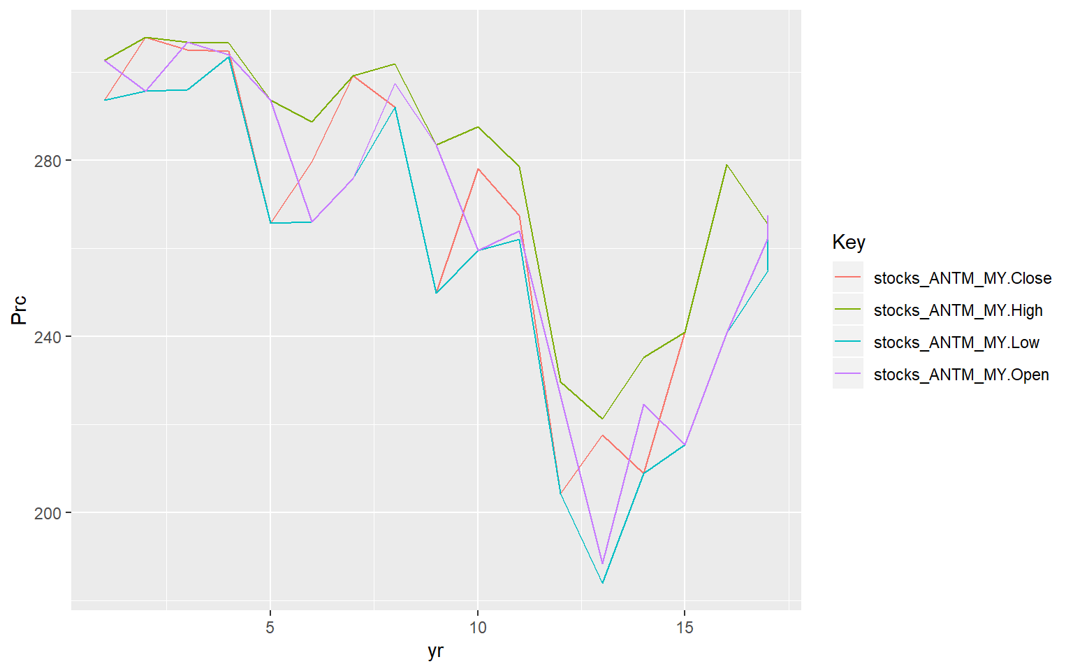

Above graph shows how price of the stocks moved in Year 2020. In the above graph, it shows weekly change in Anthem stock data i.e. open price, close price, high price, low price.

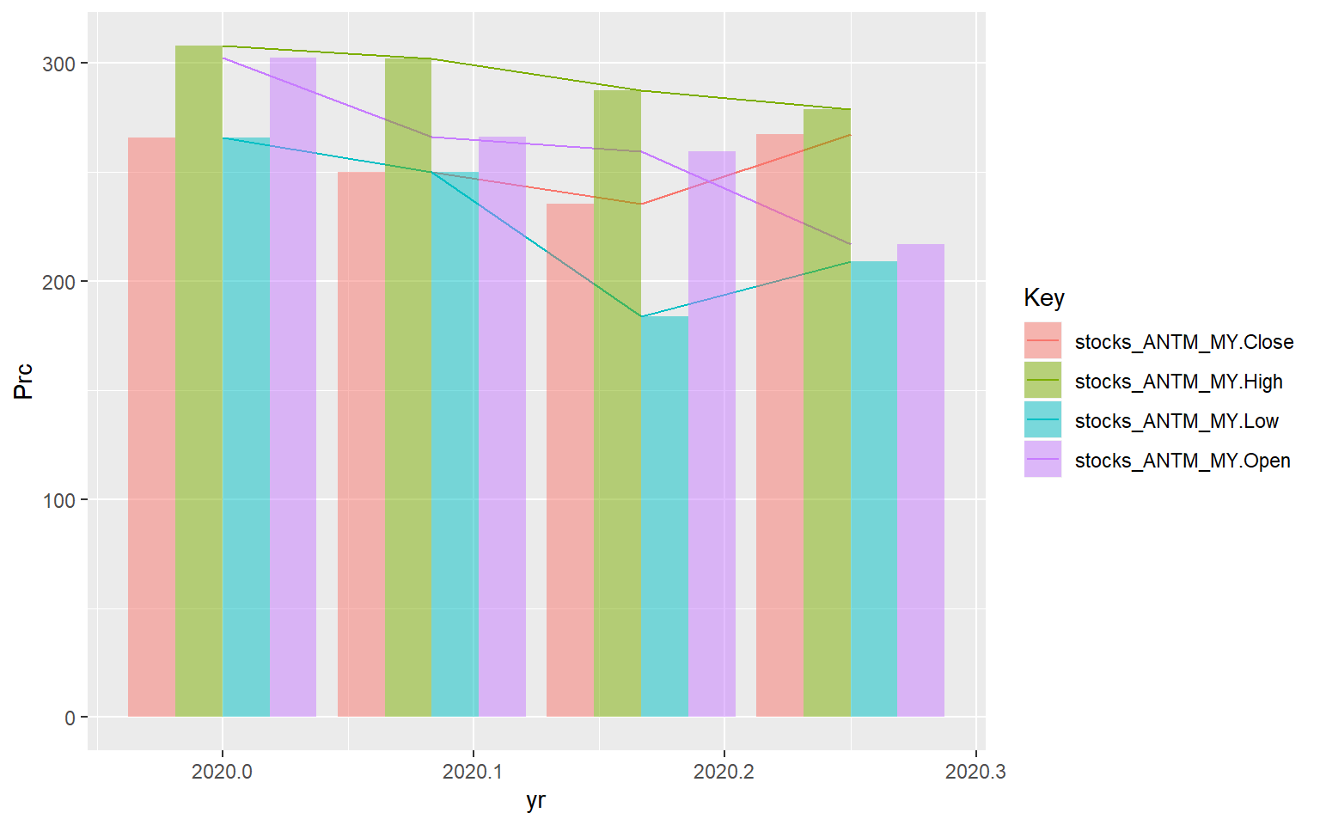

In the above graph, it shows monthly change in Anthem stock data i.e. open price, close price, high price, low price.

Periodicity of Anthem Stocks data

**periodicity**(stocks_ANTM_MY)

## Daily periodicity from 2020-01-02 to 2020-04-27

Structure of xts object:

**str**(stocks_ANTM_MY)

## An 'xts' object on 2020-01-02/2020-04-27 containing:

## Data: num [1:80, 1] 303 294 296 299 301 ...

## Indexed by objects of class: [Date] TZ: UTC

## xts Attributes:

## NULL

With the commands head() and tail() we can see the first and last 6 lines of the base. There are 6 columns with: opening price, maximum and minimum prices, closing price, volume of transactions and adjusted price. Using the command summary() we verify the descriptive statistics of each price series and volume. The command str() returns the object structure. In this case, it’s a xts object, a time series.

## Time Series Forecasting

### Data From Apr 2015 To 2020

‘stocks_ANTM’ hold data of the Anthem stocks from April 28 2015 to April 27, 2020. Head and tail for the this stock can be seen below:

**library**(forecast)

**head**(stocks_ANTM)

## [,1]

## 2015-04-28 150.15

## 2015-04-29 155.96

## 2015-04-30 151.83

## 2015-05-01 151.92

## 2015-05-04 153.45

## 2015-05-05 154.67

Hide

**tail**(stocks_ANTM)

**## [,1]**

**## 2020-04-20 262.48**

**## 2020-04-21 255.00**

**## 2020-04-22 255.09**

**## 2020-04-23 264.71**

**## 2020-04-24 265.48**

**## 2020-04-27 267.56**

Summary of the data can be seen as below :

**summary**(stocks_ANTM)

**## Index stocks_ANTM**

**## Min. :2015-04-28 Min. :117.0**

**## 1st Qu.:2016-07-26 1st Qu.:145.2**

**## Median :2017-10-24 Median :195.9**

**## Mean :2017-10-25 Mean :206.5**

**## 3rd Qu.:2019-01-26 3rd Qu.:262.8**

**## Max. :2020-04-27 Max. :317.6**

Structure of the xts object, it has data and Index which can be used to plot and perform data operation.

**str**(stocks_ANTM)

## An 'xts' object on 2015-04-28/2020-04-27 containing:

## Data: num [1:1259, 1] 150 156 152 152 153 ...

## Indexed by objects of class: [Date] TZ: UTC

## xts Attributes:

## NULL

Plot below shown how Boing share has moved along the time :

**plot**(stocks_BA)

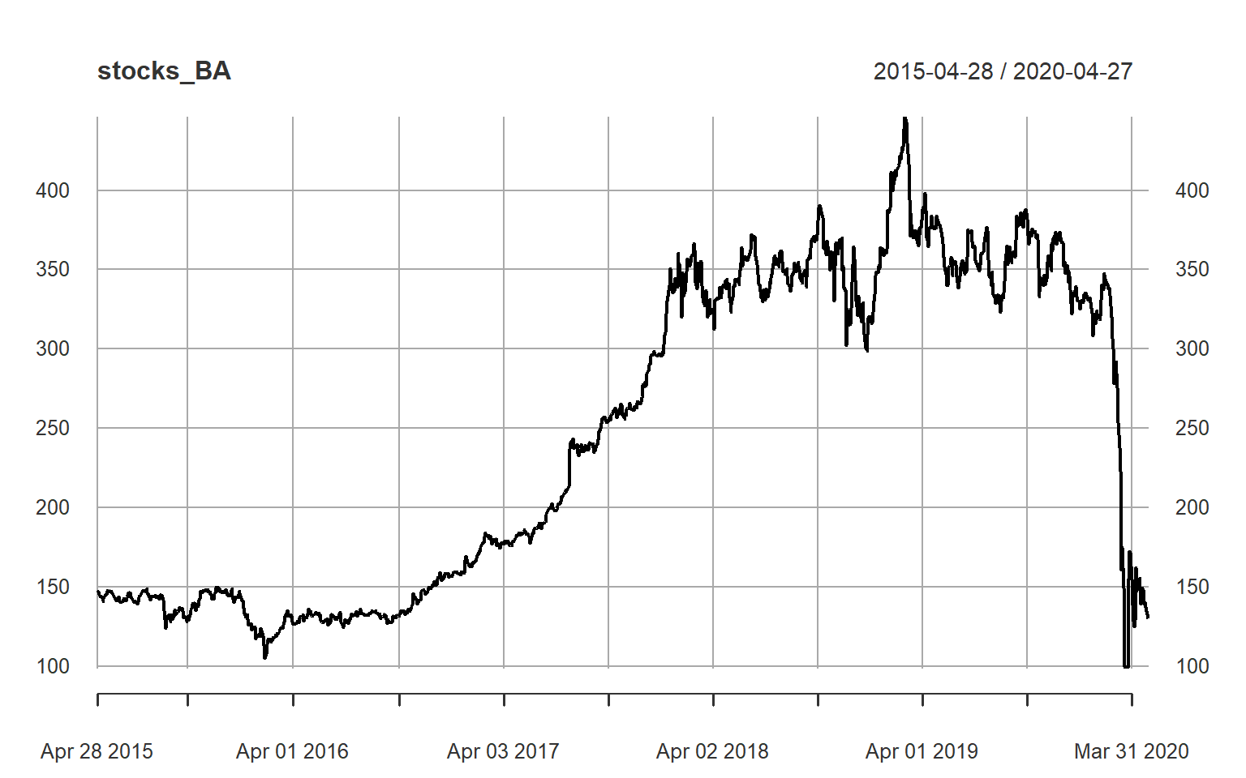

Auto correlation frequency plot for Anthem data from for first 30 lags, going be 1 lag default check.

**acf**(stocks_ANTM)

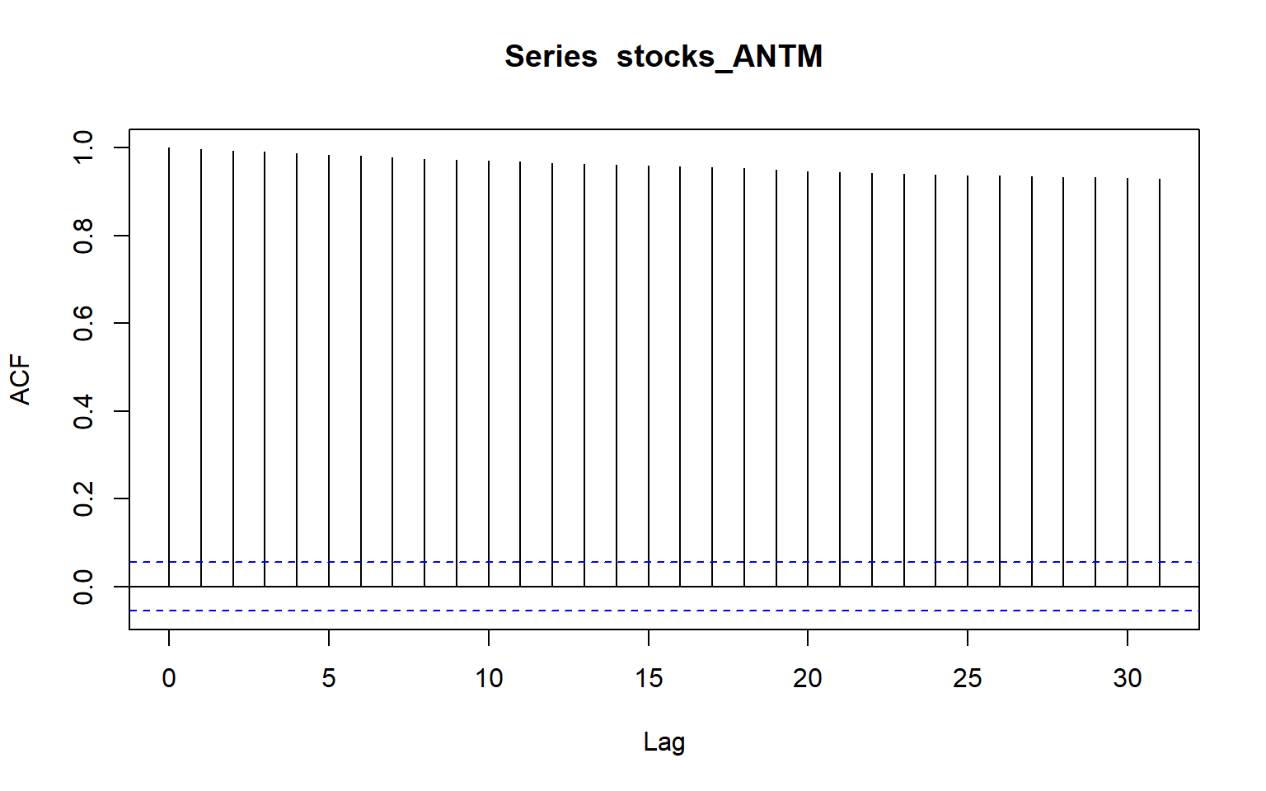

ACF Plot for Anthem:

acf_ANTM = **acf**(stocks_ANTM,lag.max = 30)

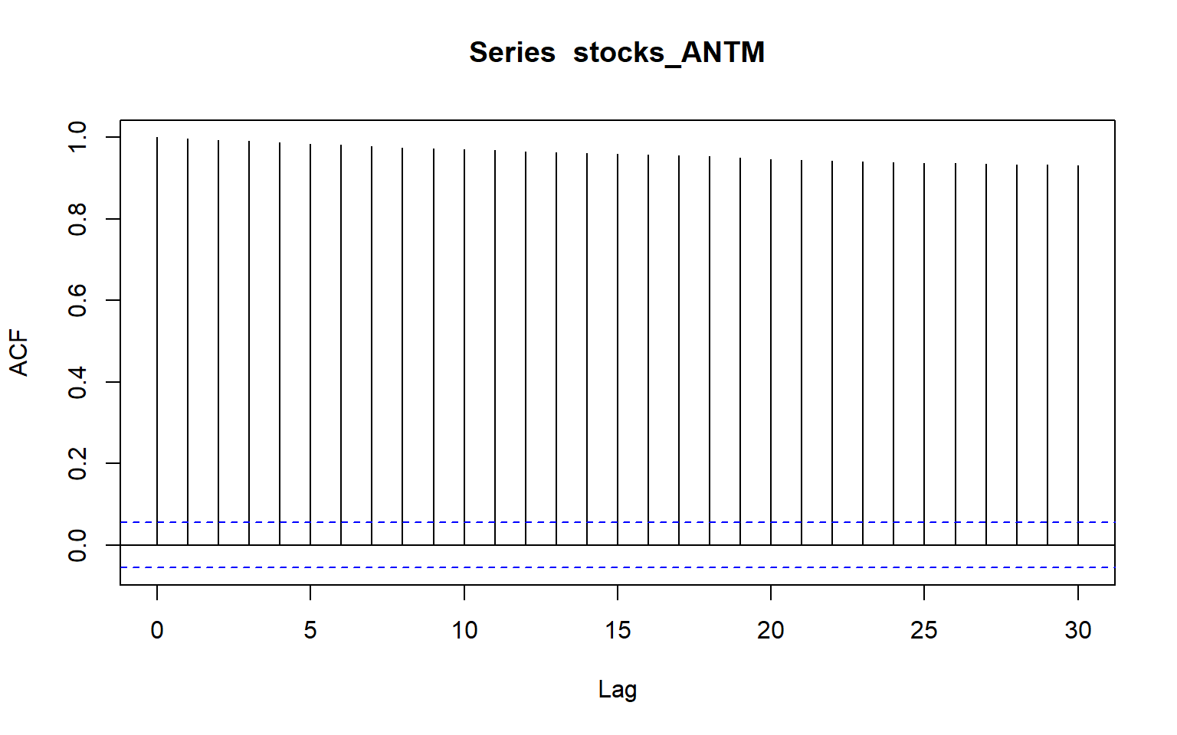

ACF Plot for Boing:

acf_BA = **acf**(stocks_BA,lag.max = 30)

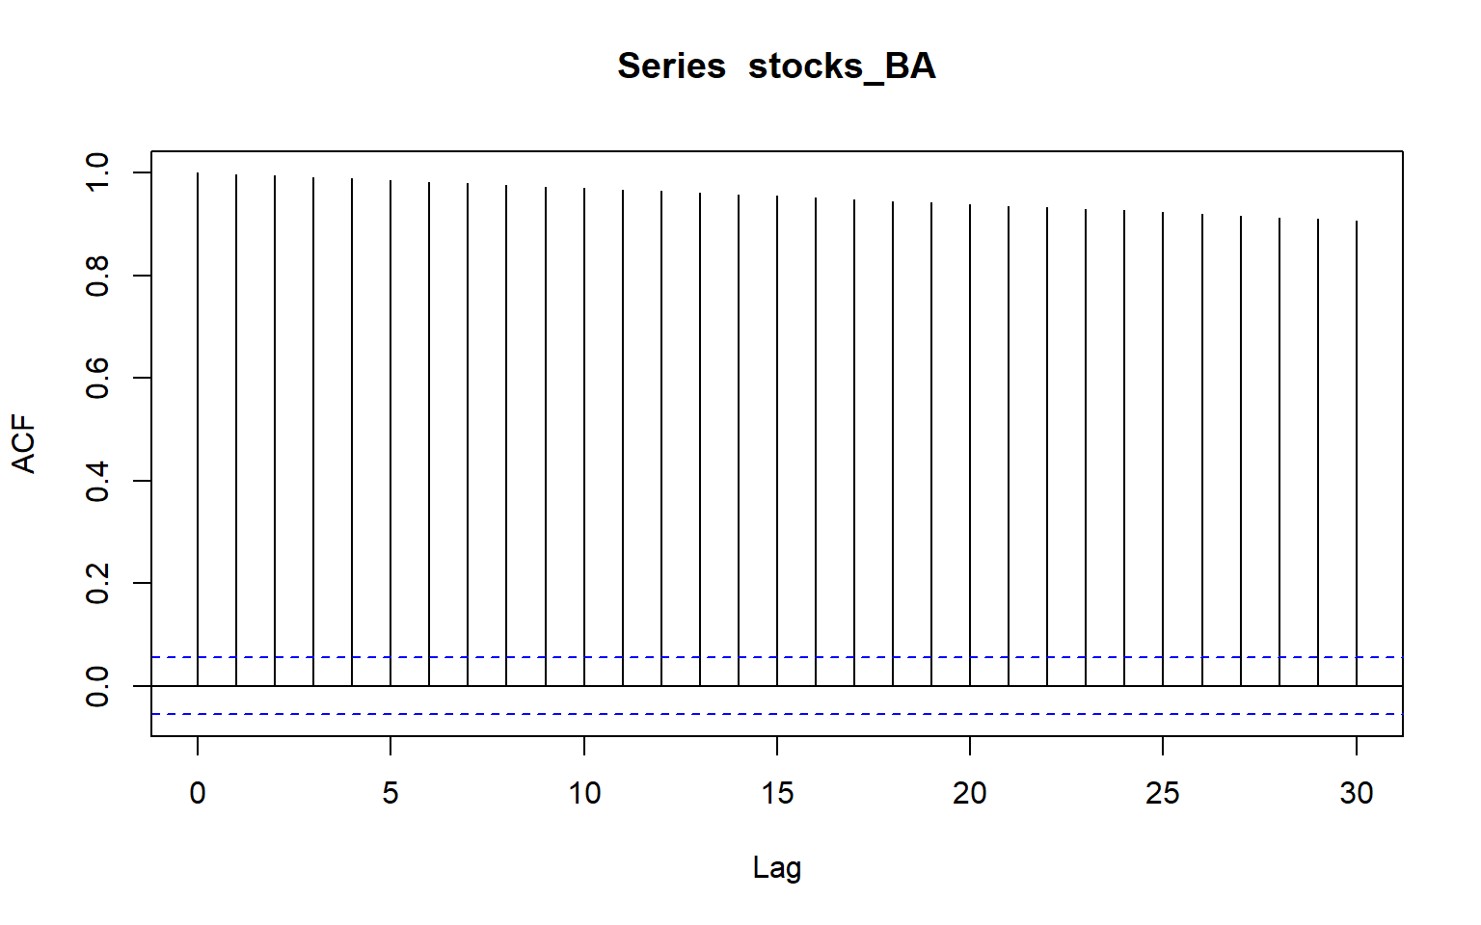

ACF Plot for ANET:

acf_ANET = **acf**(stocks_ANET,lag.max = 30)

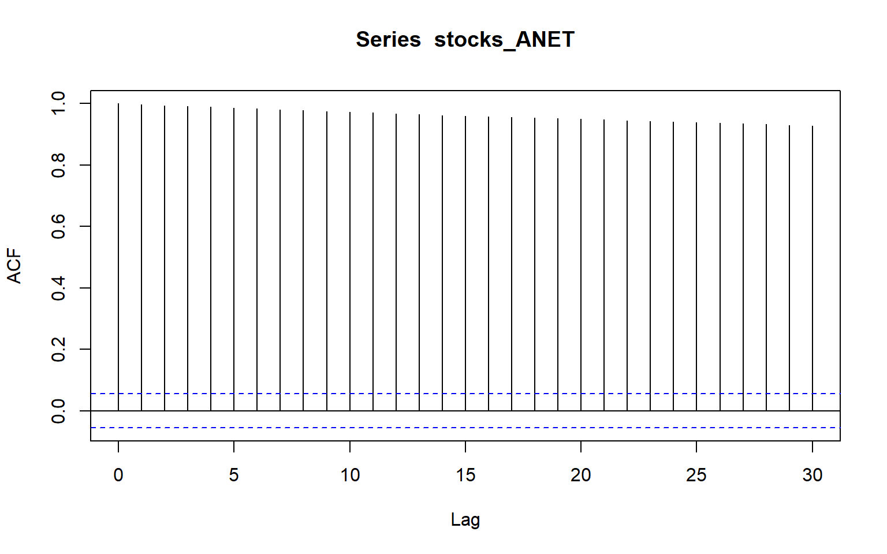

Follow shows how Anthem data is distributed over years :

**autoplot**(stocks_ANTM)

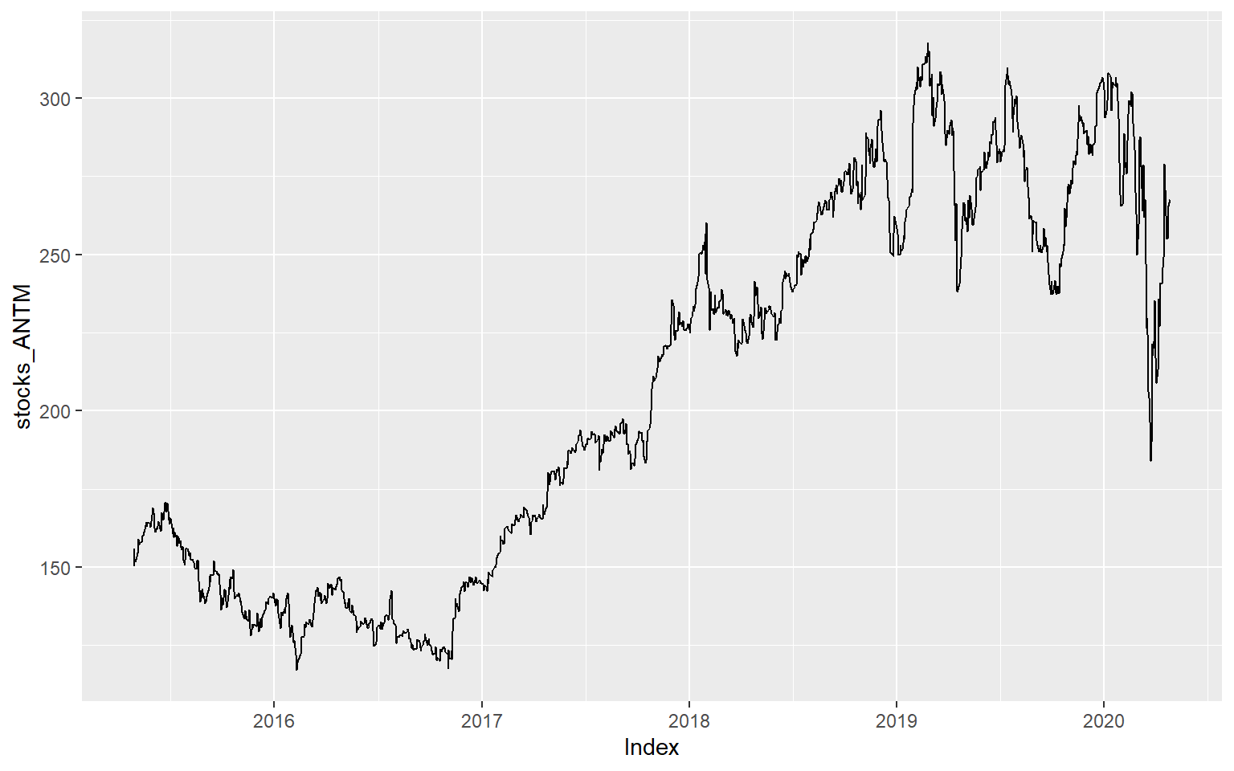

Frequency of data is 1 , which mean that we have data mostly from each day in the data set.

**frequency**(stocks_ANTM)

## [1] 1

### Current Year Data

Now we will only analyze the data set which only contains data for 2020:

Plot for 2020 Data only

ACF plots below shows it’s not a stationary, as it shows some seasonality in the data in latter part of data. This seasonality is due to COVID-19 impact on the stocks. If you compare the same plot for full ANTHEM data , its create that this stock prices follows some study random walk model and is non-stationary data.

**acf**(stocks_ANTM_MY,lag.max = 30)

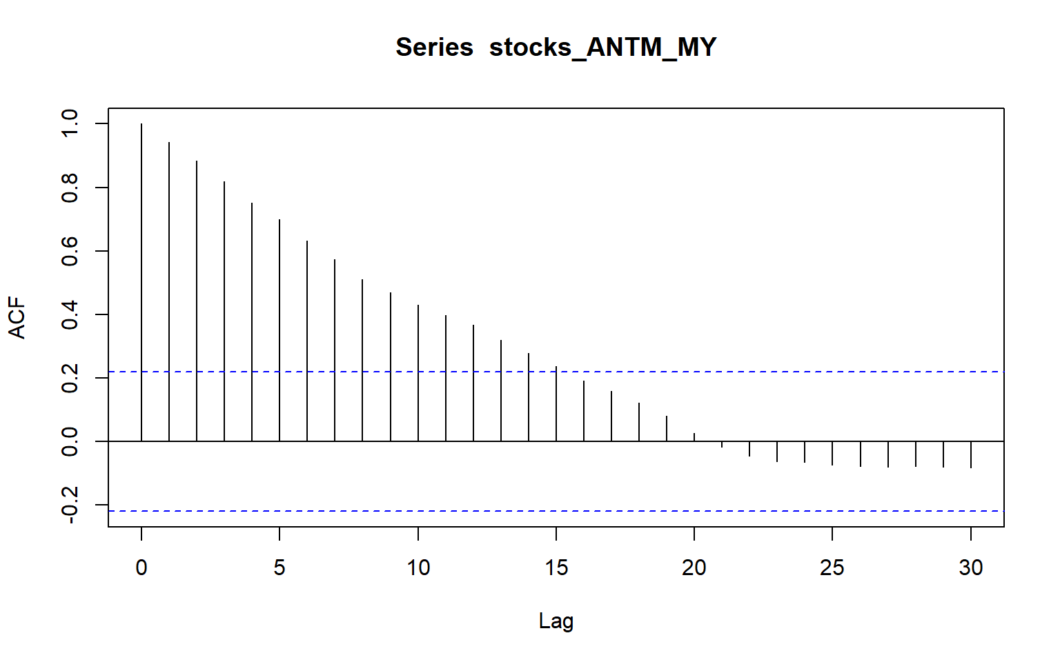

Below graph shows how ANTHEM Stock moved in the year 2020. From the tred , its very easy to see sharp decline in March and little recovery in April 2020.

**autoplot**(stocks_ANTM_MY)

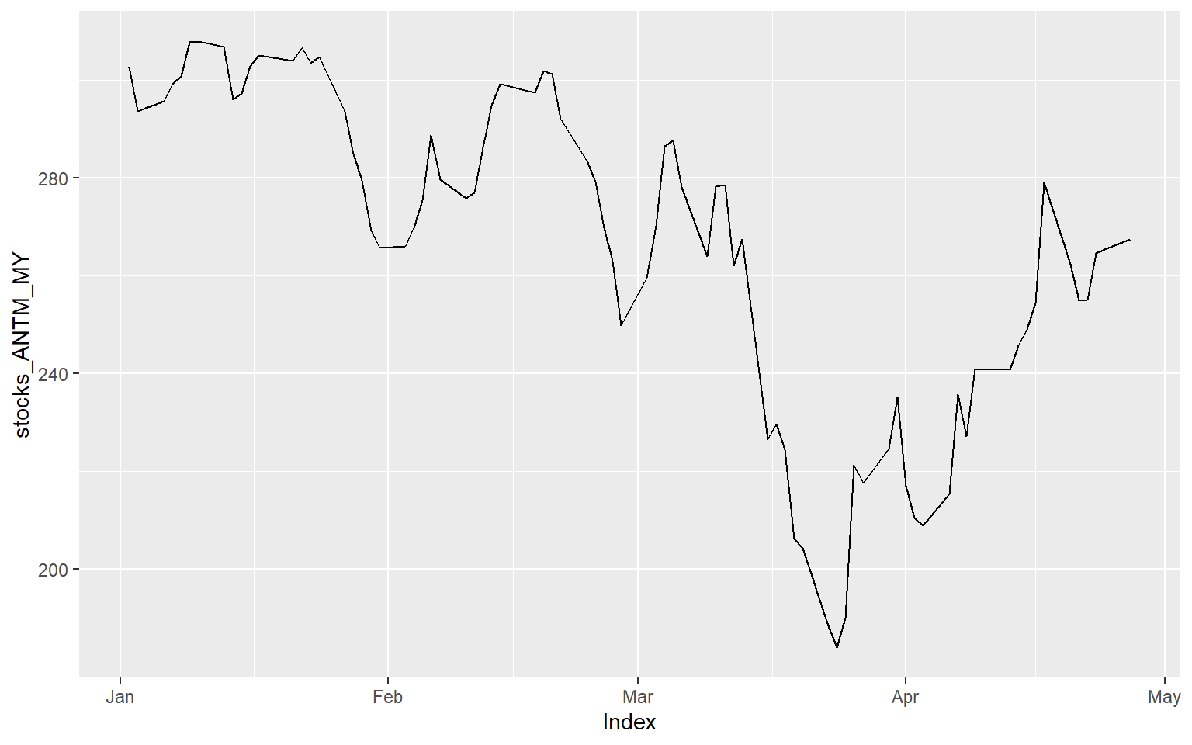

Head of Data from 2020:

**head**(stocks_ANTM_MY)

## [,1]

## 2020-01-02 302.67

## 2020-01-03 293.68

## 2020-01-06 295.75

## 2020-01-07 299.20

## 2020-01-08 300.89

## 2020-01-09 307.83

Frequency of the data is clearly daily.

**frequency**(stocks_ANTM_MY)

## [1] 1

### Data Till Dec 2019

Now Let’s check the same stocks data only until Dec 2019.

For rest of the data before 2020:

Auto correlation plot doesn’t show any difference from whole data , we will be using this data set to build our model and predict stock price in Year 2020 for stock ANTM.

**acf**(stocks_ANTM_old)

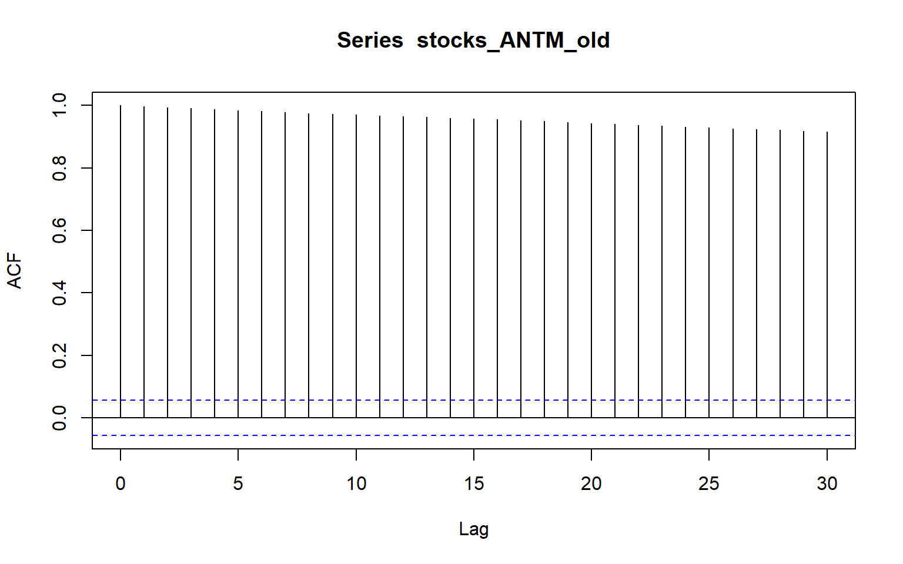

Data flow over the year until dec 2019.

**plot**(stocks_ANTM_old)

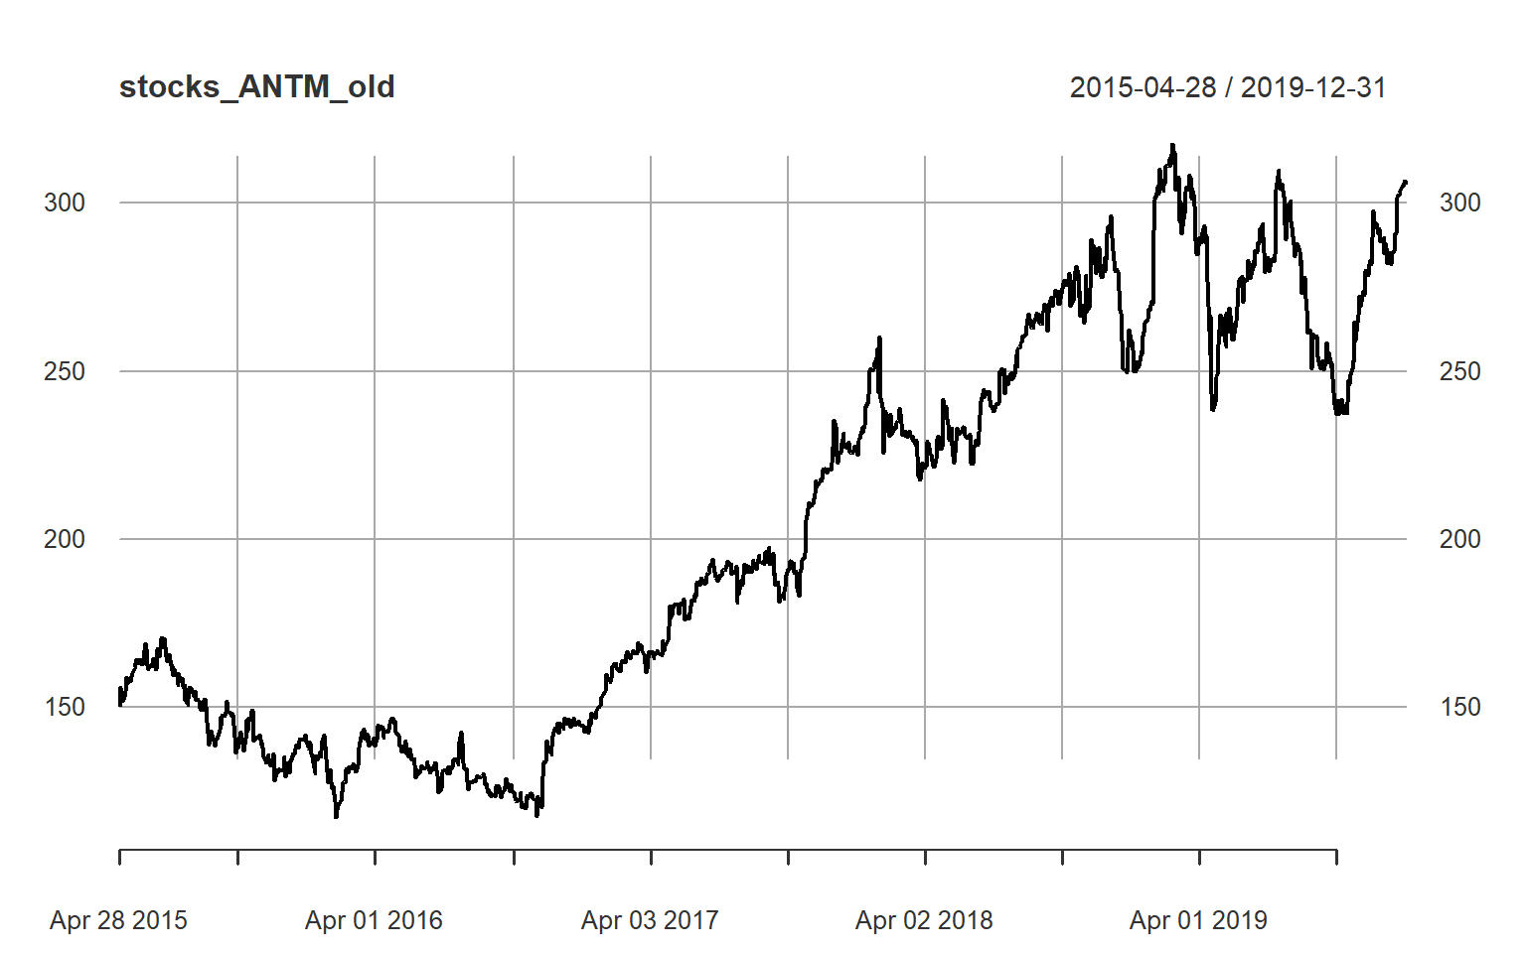

**head**(stocks_ANTM_old)

## [,1]

## 2015-04-28 150.15

## 2015-04-29 155.96

## 2015-04-30 151.83

## 2015-05-01 151.92

## 2015-05-04 153.45

## 2015-05-05 154.67

Frequency of the data is daily.

**frequency**(stocks_ANTM_old)

## [1] 1

### White Noise & Autoplots

All the above plots doesn’t show any white noise, The white noise (WN) and random walk (RW) models are very closely related. However, only the RW is always non-stationary. And we do see that our dataset is supporting random walk and its not stationary.

The ACF plots test if an individual lag autocorrelation is different than zero. An alternative approach is to use the Ljung-Box test, which tests whether any of a group of autocorrelations of a time series are different from zero.

In essence it tests the “overall randomness” based on a number of lags. If the result is a small p-value than it indicates the data are probably not white noise.

For 2020 Data we will see if it’s while noise or not:

**Box.test**(wide_data_Main_20**$**ANTM, lag = 30, fitdf = 0, type = "Lj")

##

## Box-Ljung test

##

## data: wide_data_Main_20$ANTM

## X-squared = 480.01, df = 30, p-value < 2.2e-16

**Box.test**(wide_data_Main**$**ANTM, lag = 4, fitdf = 0, type = "Lj")

##

## Box-Ljung test

##

## data: wide_data_Main$ANTM

## X-squared = 4976, df = 4, p-value < 2.2e-16

Here, we perform a Ljung-Box test on the first 24 lag autocorrelations. The resulting p-value is significant at p < .001, so this supports our ACF plot consideration above where we stated it’s likely this is not purely white noise and that some time series information exists in this data.

Following Plots of all the stocks together shows correlation in the stock, we will see how much correlation exists among these stocks:

**plot**(**cbind**(stocks_ANTM,stocks_ANET,stocks_BA))

BLACK- >ANTM  
RED-> ANET  
GREEN -> BA

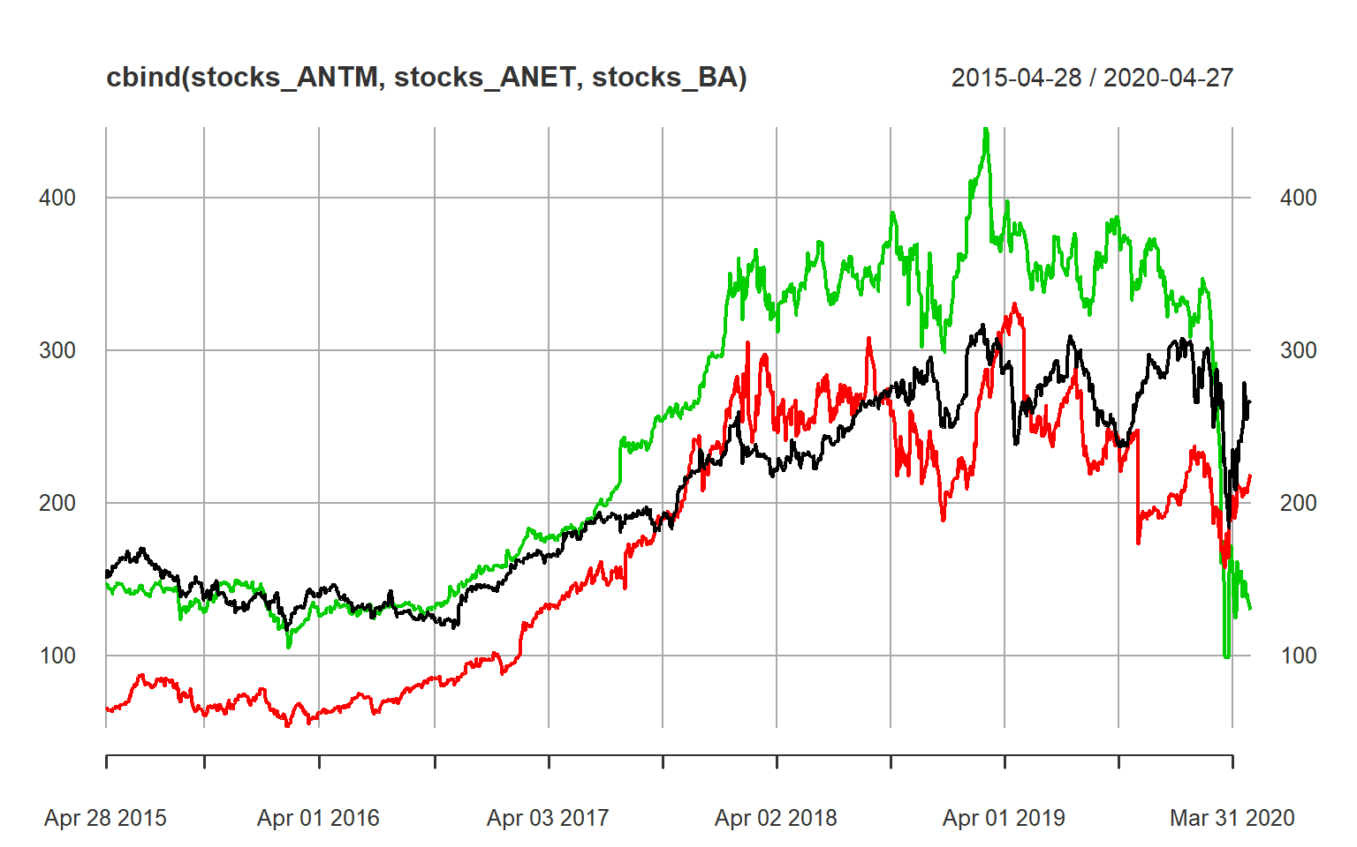

Correlation of the 2020 only data is as below:

**plot**(**cbind**(stocks_ANTM_MY,stocks_ANET_MY,stocks_BA_MY))

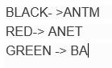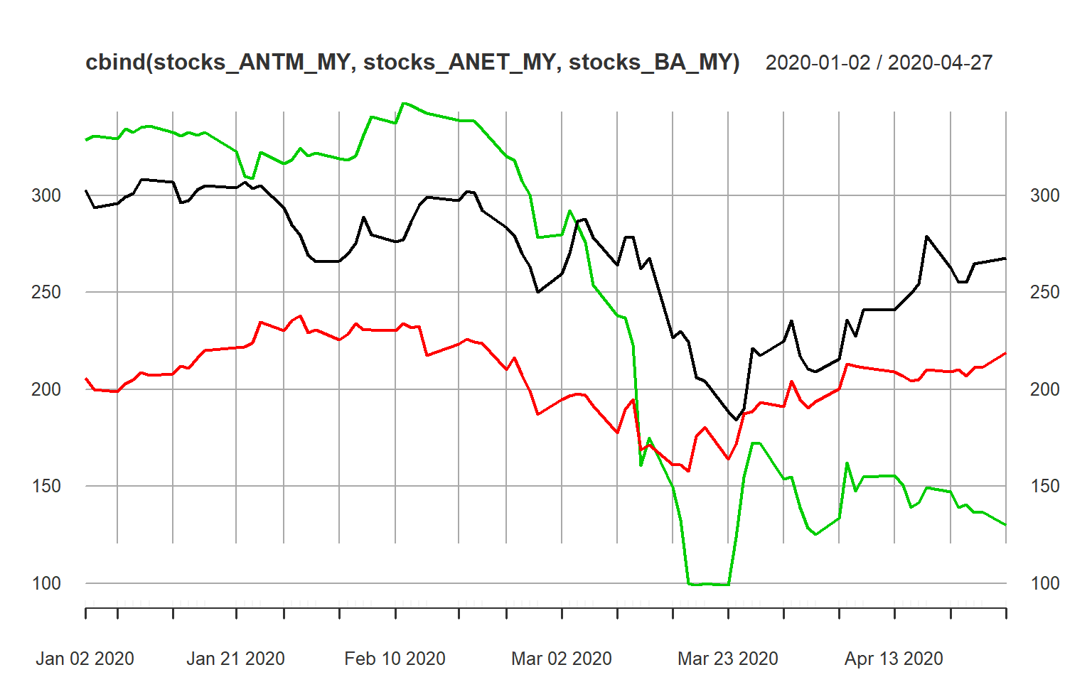 ~

Same plot for data only till Dec 2019.

**plot**(**cbind**(stocks_ANTM_old,stocks_ANET_old,stocks_BA_old))

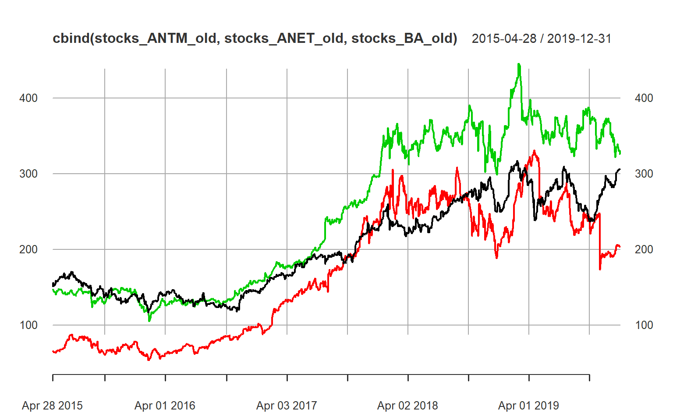

These plots suggest that these slots the stocks improved from their position from mid of 2016 though 2018, and then it remained constant in progress until Late 2019 and early 2020.

The trend is the long-term increase or decrease in the data. There is an increasing trend in the cement data. the seasonal pattern occurs when a time series is affected by seasonal factors such as the time of the year or the day of the week. The daily data of the stocks_ANTM doesn’t show any seasonality in the graph.

the cycle occurs when the data exhibit rises and falls that are not of a fixed period. These fluctuations are usually due to economic conditions and are often related to the “business cycle”. We can see a few cycles in our in stocks_ANTM data from 2015 to 2018 and then in 2020 we have sudden drop due to covid 19.

### Autocorrelation Of Time Series

Another way to look at time series data is to plot each observation against another observation that occurred sometime previously. For example, we could plot yt against yt-1 . This is called a lag plot because you are plotting the time series against lags of itself.

Below lag plots shows how data was very moving along mean zero but April 2019 and Mar 2020 shows some spiked and random changes in the lags. The Lags in the Latter month of March 2020 is more prominent and can be seen very clearly how it has impacted the stock price.

**plot**(**diff**(stocks_ANTM))

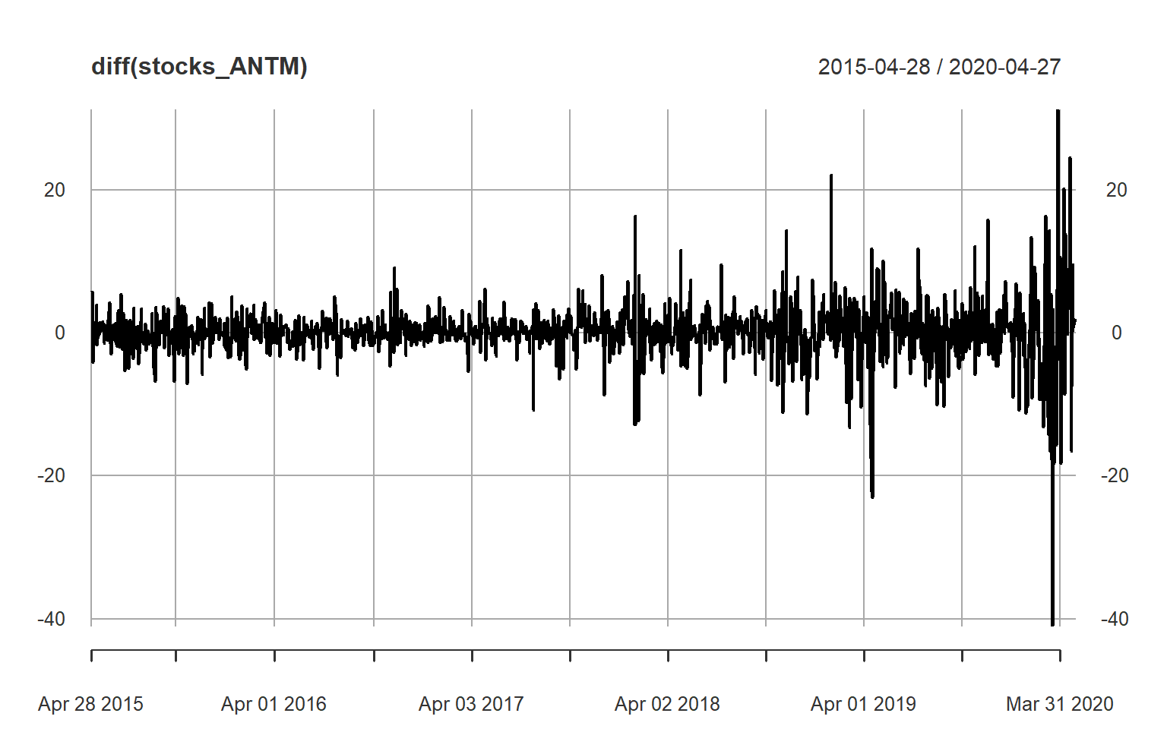

Hide

**plot**(**diff**(stocks_BA))

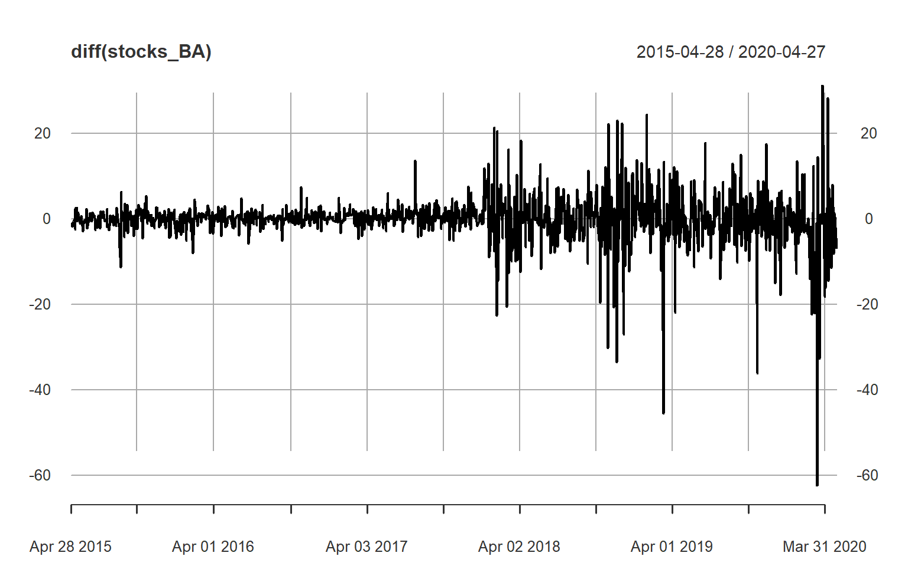

Hide

**plot**(**diff**(stocks_ANET))

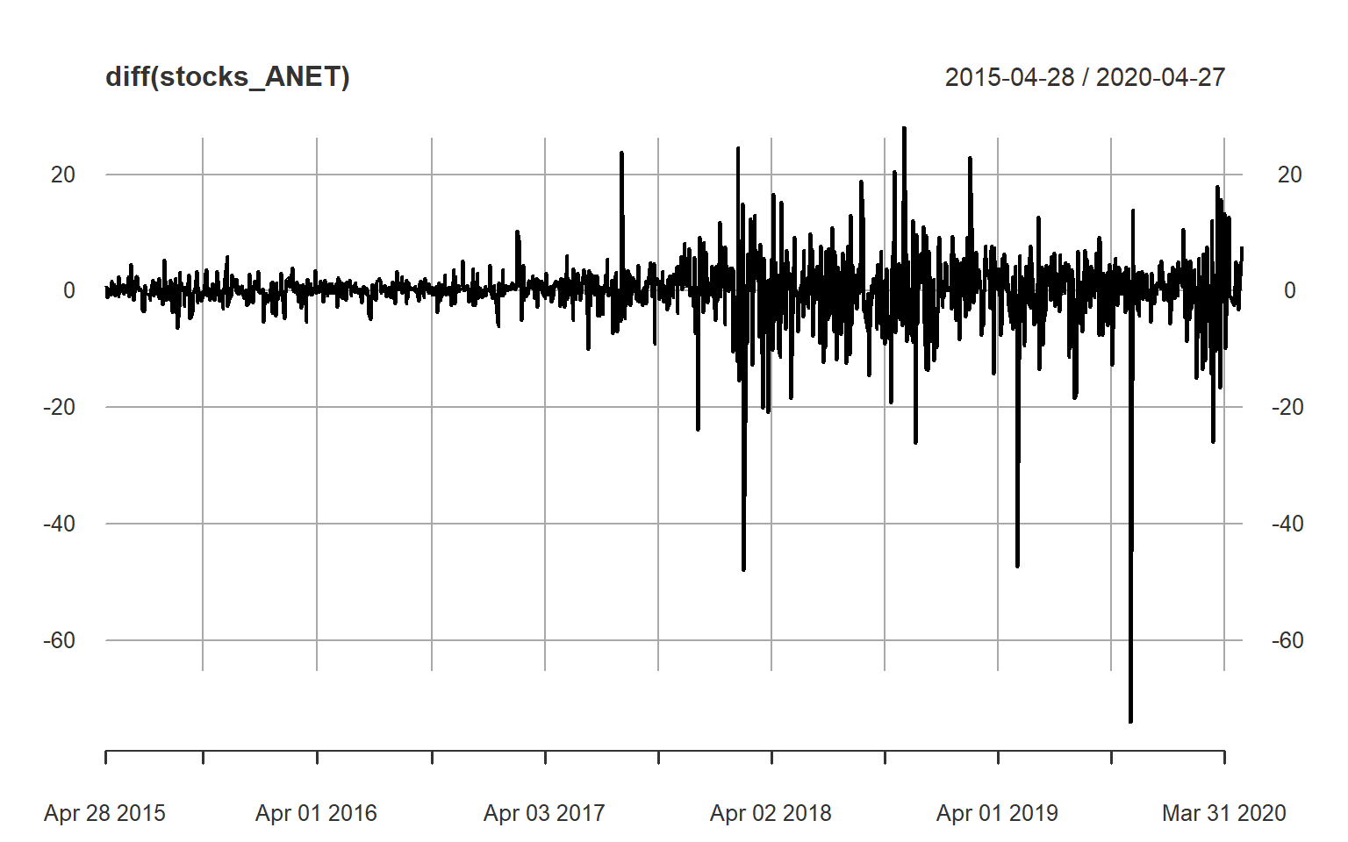

Correlation in the stocks is very high and COR function also shows the same. Correlation on Full Stock data from 2015- 2020:

*# Correlation Between the stocks*

psych**::pairs.panels**(**as.matrix**(wide_data_Main[,**c**('ANTM','BA','ANET')]))

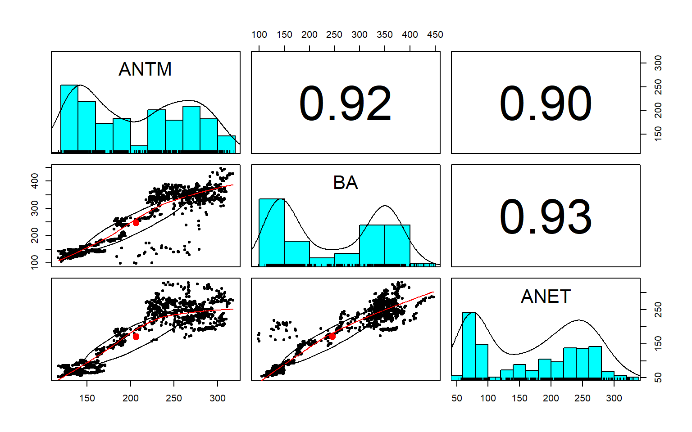

Correlation among data before 2020:

psych**::pairs.panels**(**as.matrix**(wide_data_Main_Old[,**c**('ANTM','BA','ANET')]))

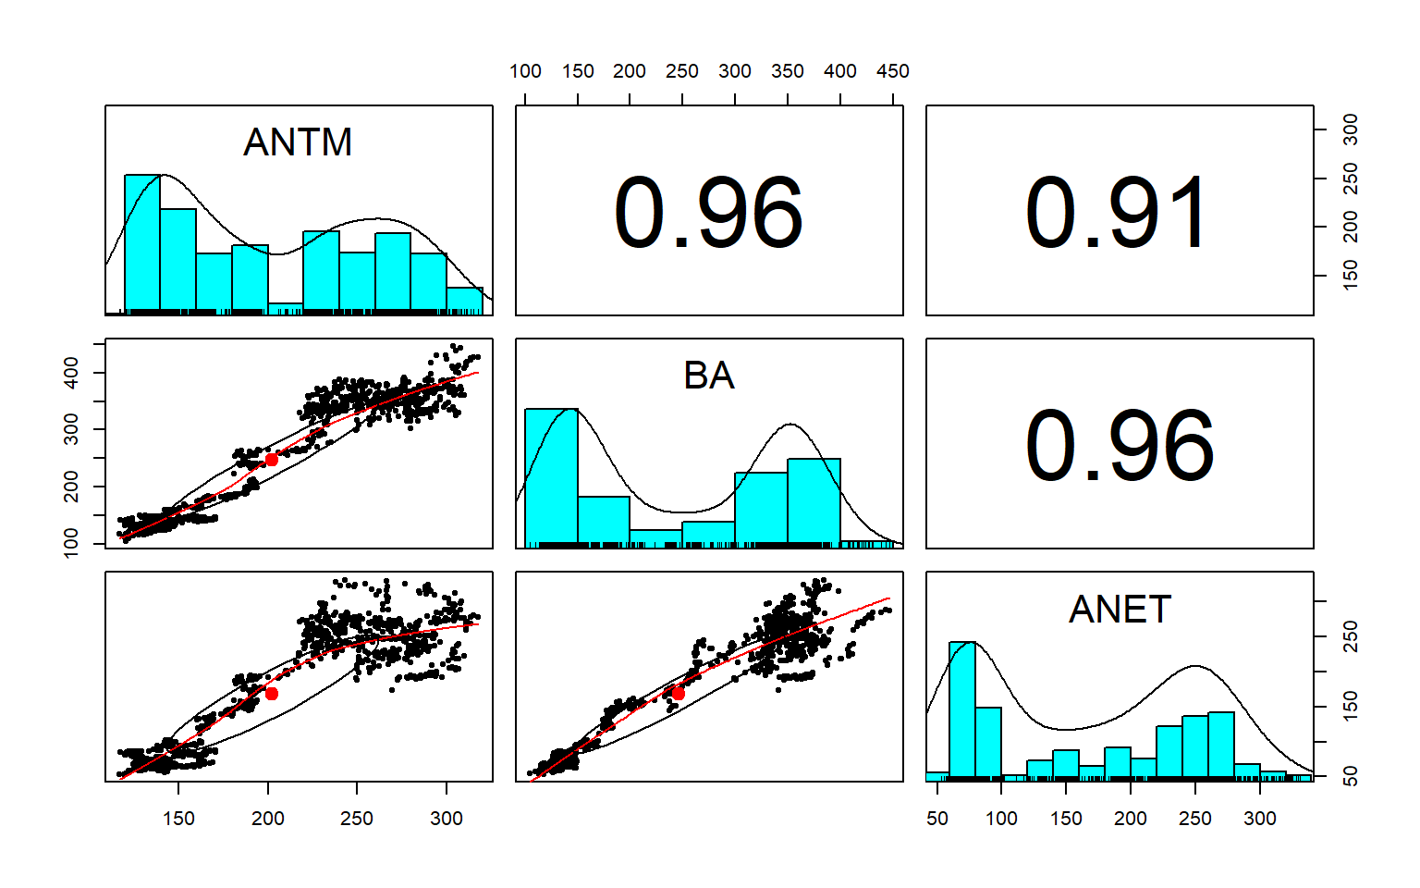

Correlation only for 2020 data:

psych**::pairs.panels**(**as.matrix**(wide_data_Main_20[,**c**('ANTM','BA','ANET')]))

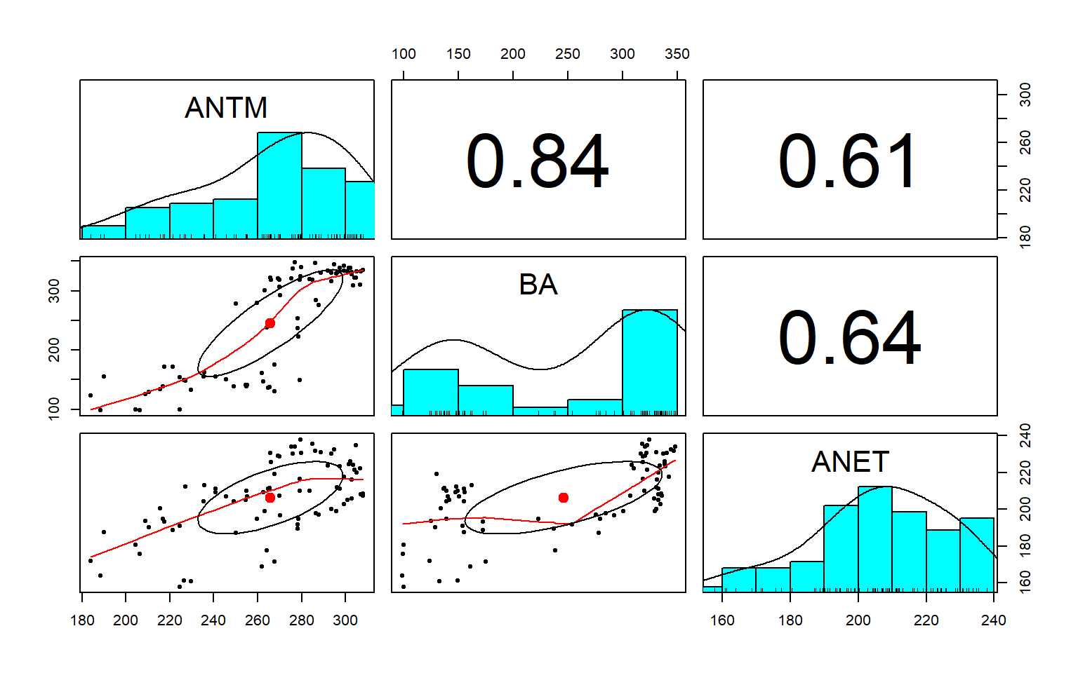

**class**(stocks_ANTM)

## [1] "xts" "zoo"

White Noise : Time series that show no autocorrelation are called “white noise”. Above plots shows that its of type of Random Walk model , and the (MA Model) Moving Average model should give better estimates of this index.

# BUILDING MODEL

### Fitting Data

For a given time series x we can fit the autoregressive (AR) model using the arima() command and setting order equal to c(1, 0, 0). Note for reference that an AR model is an ARIMA(1, 0, 0) model.

Fitting Full data :

Fitting Anthem full year data from 2015 to 2020 using AR Model, and MA Model.

*# Fit with Full Data*

AR_ANTM <- **arima**(stocks_ANTM, order = **c**(1,0,0))

MA_ANTM <- **arima**(stocks_ANTM, order = **c**(0,0,1))

AR_ANTM_fit <- **as.ts**(stocks_ANTM) **-** **resid**(AR_ANTM)

MA_ANTM_fit <- **as.ts**(stocks_ANTM) **-** **resid**(MA_ANTM)

**summary**(AR_ANTM)

##

## Call:

## arima(x = stocks_ANTM, order = c(1, 0, 0))

##

## Coefficients:

## ar1 intercept

## 0.9978 222.5894

## s.e. 0.0018 45.1308

##

## sigma^2 estimated as 16.88: log likelihood = -3568.12, aic = 7142.25

##

## Training set error measures:

## ME RMSE MAE MPE MAPE MASE

## Training set 0.0542719 4.108244 2.529343 -0.01210249 1.19899 1.002039

## ACF1

## Training set -0.0209907

**summary**(MA_ANTM)

##

## Call:

## arima(x = stocks_ANTM, order = c(0, 0, 1))

##

## Coefficients:

## ma1 intercept

## 0.9678 206.4969

## s.e. 0.0058 1.7300

##

## sigma^2 estimated as 973.9: log likelihood = -6119.59, aic = 12245.19

##

## Training set error measures:

## ME RMSE MAE MPE MAPE MASE ACF1

## Training set 0.01566924 31.20706 27.96412 -4.741534 15.01558 11.07842 0.9108069

Sigma^2 is equivalent of R2 shows AR Model is explaining more variability of the data compared with MA model.   
**sigma^2 estimated as 16.88  
sigma^2 estimated as 973.9:**

Below plot suggest how actual data fits with AR Model and MA model. WE can see that AR Model data fits very well with actual data, where as Any model data does not fits well with the base model data.

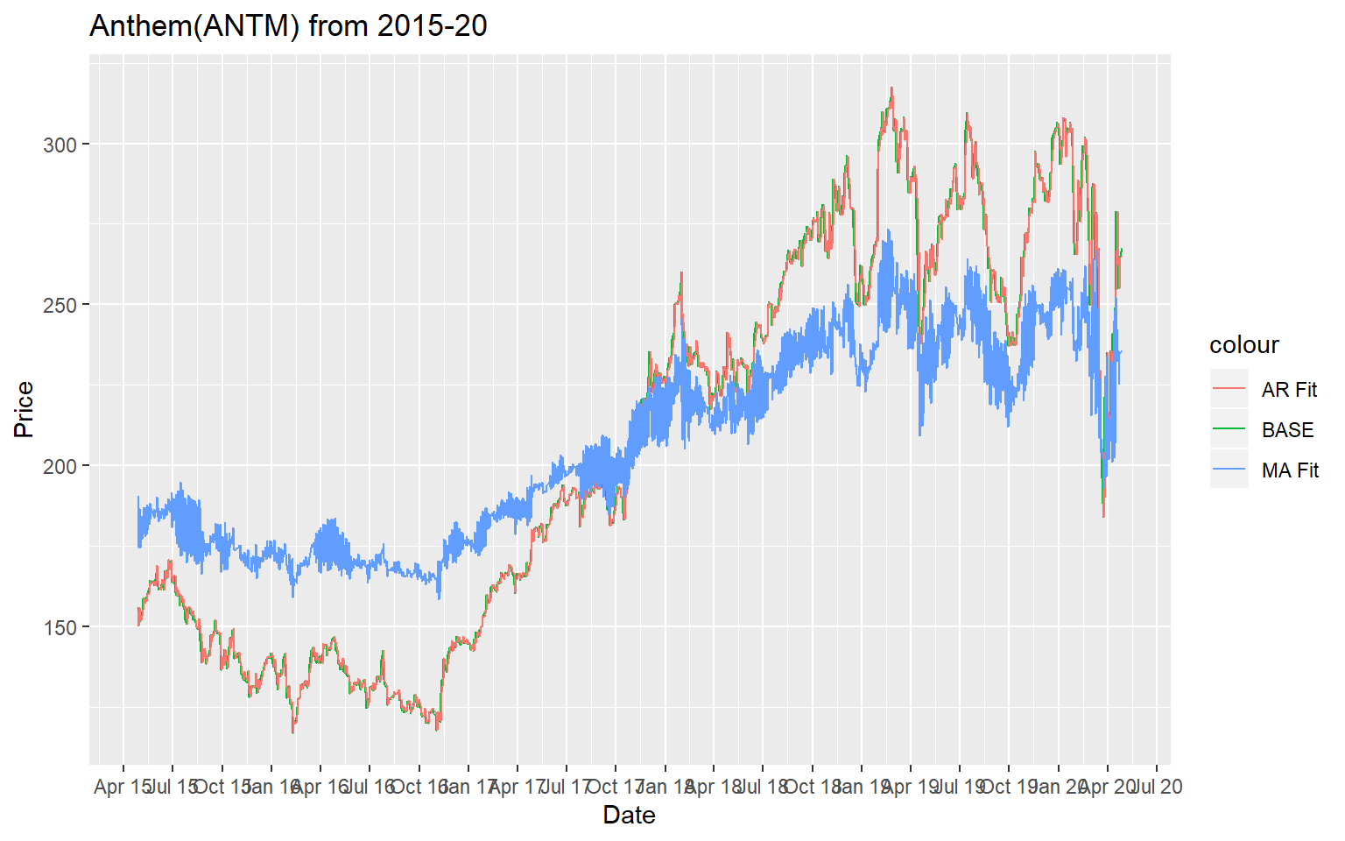

### Fit With Only Data After 2020:

We will use the same AR and MA model , and we will try to predict stock data for year 2020, from the fitted model of the data tell December 2019.

*# plot.ts(stocks_ANTM_MY)*

AR_ANTM_MY <- **arima**(stocks_ANTM_MY, order = **c**(1,0,0))

MA_ANTM_MY <- **arima**(stocks_ANTM_MY, order = **c**(0,0,1))

AR_ANTM_MY_fit <- **as.ts**(stocks_ANTM_MY) **-** **resid**(AR_ANTM_MY)

MA_ANTM_MY_fit <- **as.ts**(stocks_ANTM_MY) **-** **resid**(MA_ANTM_MY)

*# points(AR_ANTM_MY_fit, type = "l", col = 4, lty = 2)*

*# points(MA_ANTM_MY_fit, type = "l", col = 3, lty = 3)*

**ggplot**(stocks_ANTM_MY, **aes**(x = **index**(stocks_ANTM_MY))) **+**

**geom_line**(**aes**(y= **coredata**(stocks_ANTM_MY) , color="BASE")) **+**

**geom_line**(**aes**(y = AR_ANTM_MY_fit, color = "AR Fit")) **+**

**geom_line**(**aes**(y = MA_ANTM_MY_fit, color = "MA Fit"))**+**

**ggtitle**("Anthem(ANTM) from 2020") **+**

**scale_x_date**(date_labels = "%b %y", date_breaks = "3 months")**+**

**xlab**("Date") **+** **ylab**("Price")

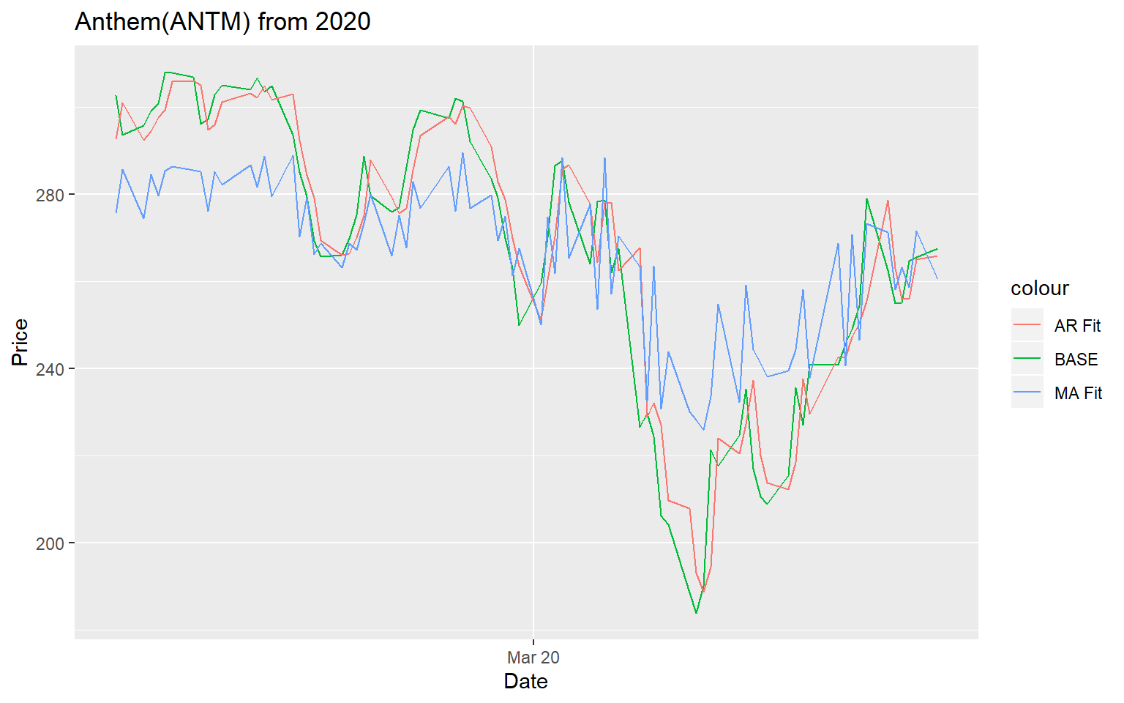

From the above plot we can very clearly see that The red line which indicates the autoregressive model is very close to the baseline which represents the actual data movement, when compared with moving average MA model the blue line is very far from the actual data and hence does not represent a right prediction off the stock price in year 2020.

Fit With Data Before 2020

Now we will use the data Until December 2019 and see how that fits with the data off AR and MA model. We can very clearly see that AR model is doing better and is very close to the base line, whereas MA model is not staying close to the actual data.

*# Fit with Data before 2020*

AR_ANTM_old <- **arima**(stocks_ANTM_old, order = **c**(1,0,0))

MA_ANTM_old <- **arima**(stocks_ANTM_old, order = **c**(0,0,1))

AR_ANTM_old_fit <- **as.ts**(stocks_ANTM_old) **-** **resid**(AR_ANTM_old)

MA_ANTM_old_fit <- **as.ts**(stocks_ANTM_old) **-** **resid**(MA_ANTM_old)

**ggplot**(stocks_ANTM_old, **aes**(x = **index**(stocks_ANTM_old))) **+**

**geom_line**(**aes**(y= **coredata**(stocks_ANTM_old) , color="BASE")) **+**

**geom_line**(**aes**(y = AR_ANTM_old_fit, color = "AR Fit")) **+**

**geom_line**(**aes**(y = MA_ANTM_old_fit, color = "MA Fit"))**+**

**ggtitle**("Anthem(ANTM) Before 2020") **+**

**scale_x_date**(date_labels = "%b %y", date_breaks = "3 months")**+**

**xlab**("Date") **+** **ylab**("Price")

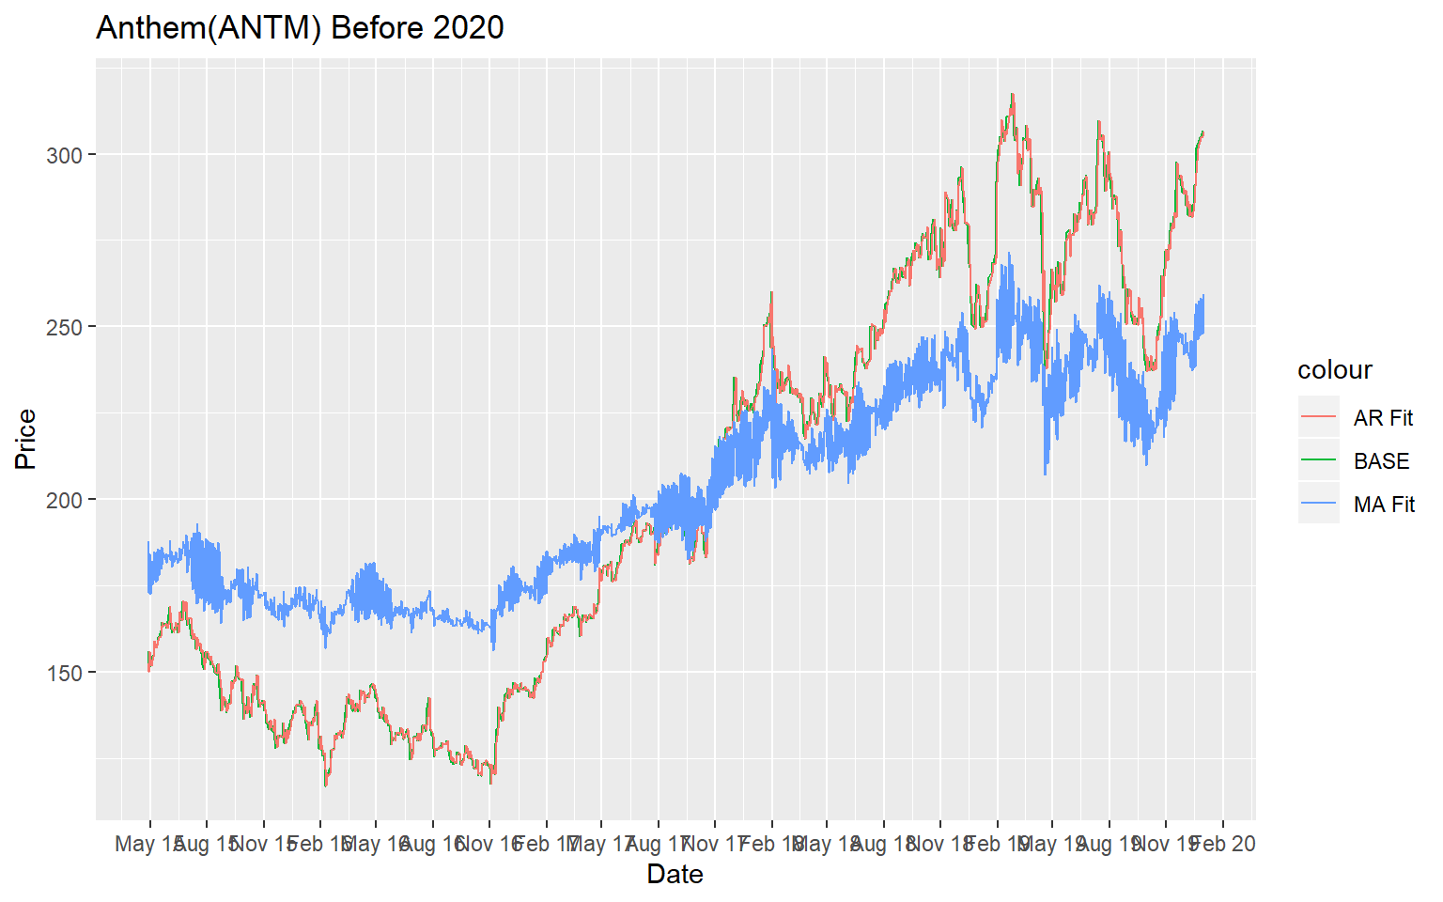

## Predicting Time Series data

We will evaluate all the data models and see its prediction using both the models with Current Years data.

We can use predict command to predict the future days price by using n.ahead command. Here AR(1) model is the so-called "random walk" model (without drift): it assumes that, from one period to the next, the original time series merely takes a random "step" away from its last recorded position.

*# Make a 1-step through 10-step forecast based on MA*

**predict**(AR_ANTM,n.ahead = 10)

## $pred

## Time Series:

## Start = 1260

## End = 1269

## Frequency = 1

## [1] 267.4619 267.3640 267.2663 267.1688 267.0716 266.9745 266.8777 266.7811

## [9] 266.6846 266.5884

##

## $se

## Time Series:

## Start = 1260

## End = 1269

## Frequency = 1

## [1] 4.108244 5.803600 7.100186 8.189663 9.146360 10.008444 10.798612

## [8] 11.531670 12.217916 12.864855

### Using Full Data

Below graph shows how the price would be if we use AR(1) model to prodict. We are using full data set to predict future price after April 27 2020.

*# Plot the series plus the forecast and 95% prediction intervals*

AR_forecasts <- **predict**(AR_ANTM, n.ahead = 300)**$**pred

AR_forecast_se <- **predict**(AR_ANTM, n.ahead = 300)**$**se

**plot.ts**(stocks_ANTM)

**points**(AR_forecasts, type = "l", col = 4,lty=2)

*# points(AR_forecasts - AR_forecast_se, type = "l", col = 2, lty = 1)*

**points**(AR_forecasts **-** 2**\***AR_forecast_se, type = "l", col = 2, lty = 1)

**points**(AR_forecasts **+** 2**\***AR_forecast_se, type = "l", col = 2, lty = 1)

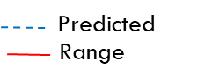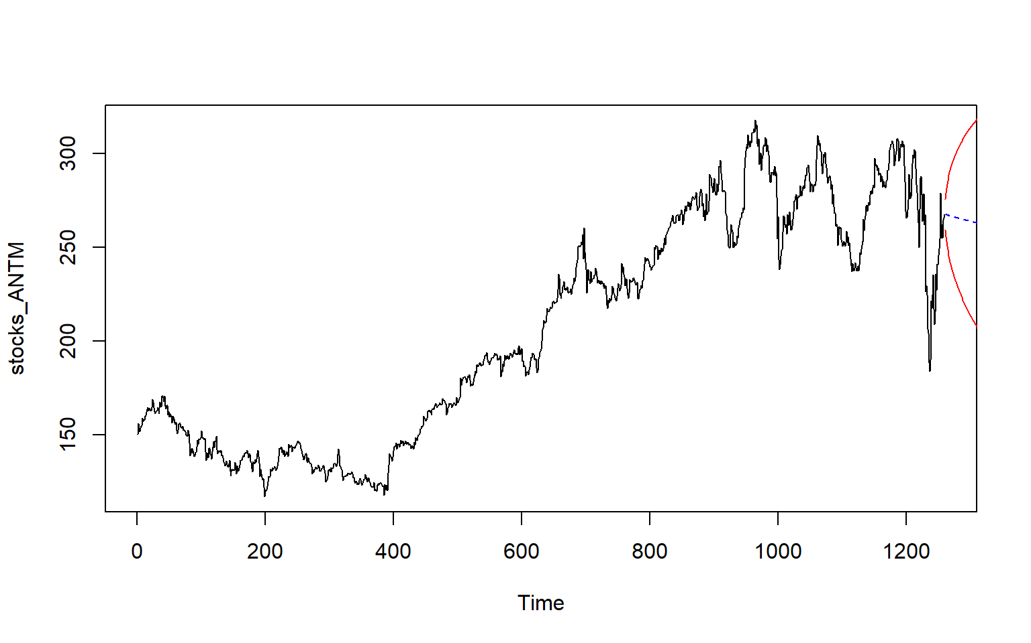

We can also user forecast command from forecast package to achieve this.

*#--------------------*

**library**(forecast)

*# We can then use the ARIMA model to make forecasts for future values of the time series, using the "forecast.*

AR_ANTM_forcast <- **forecast**(AR_ANTM, h=30,level=**c**(99.5))

*# We can plot the observed value of stock for the , as well as the predicted that would be predicted for these and for the next 30 days using our ARIMA(0,0,1) model,*

**plot**(AR_ANTM_forcast)

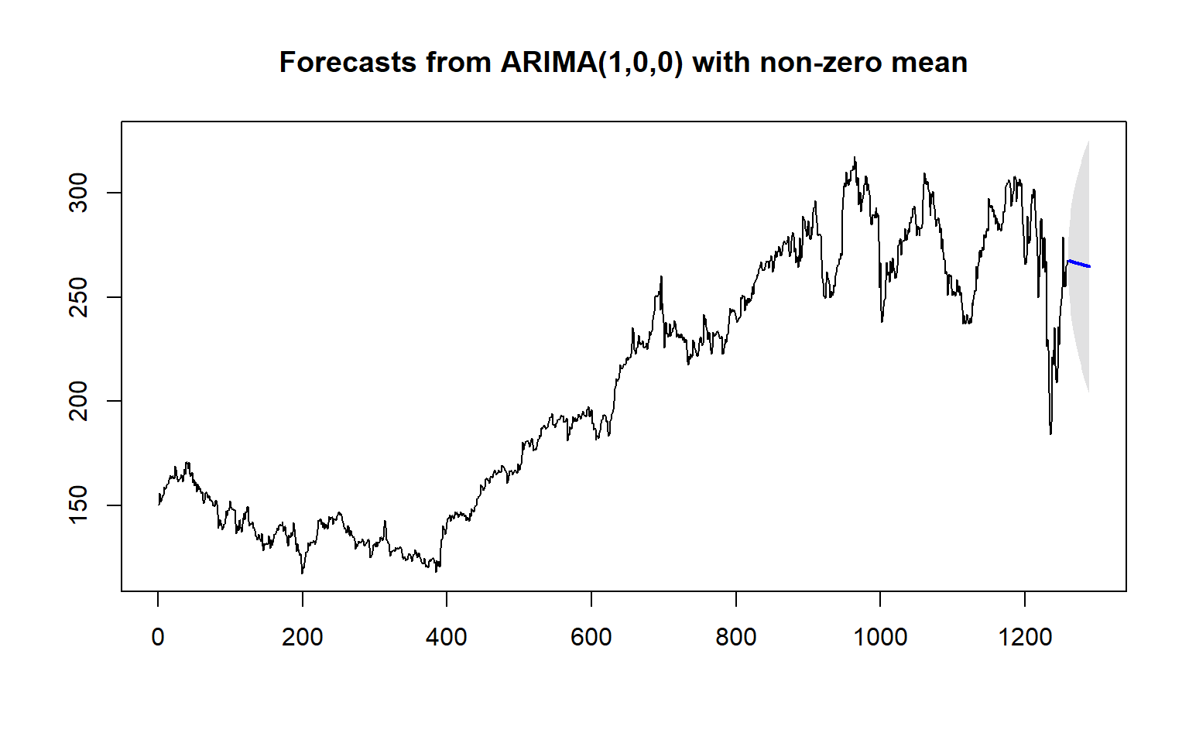

### Using Data Fit Till Dec 2019

Now let use AR(1) model fit from data of only dec 2019, and try to predict 2020 stock price. Predicting next 300 days stock prices for the Anthem stock , based on AR(1) and MA(1) model.

*#--------------------  
# Plot of original data set and predication of 2020 based on old data*

AR_old_forecasts <- **predict**(AR_ANTM_old, n.ahead = 300)**$**pred

AR_old_forecast_se <- **predict**(AR_ANTM_old, n.ahead = 300)**$**se

**plot.ts**(stocks_ANTM)

**points**(AR_old_forecasts, type = "l", col = 4,lty=2)

**points**(AR_old_forecasts **-** 2**\***AR_old_forecast_se, type = "l", col = 2, lty = 1)

**points**(AR_old_forecasts **+** 2**\***AR_old_forecast_se, type = "l", col = 2, lty = 1)

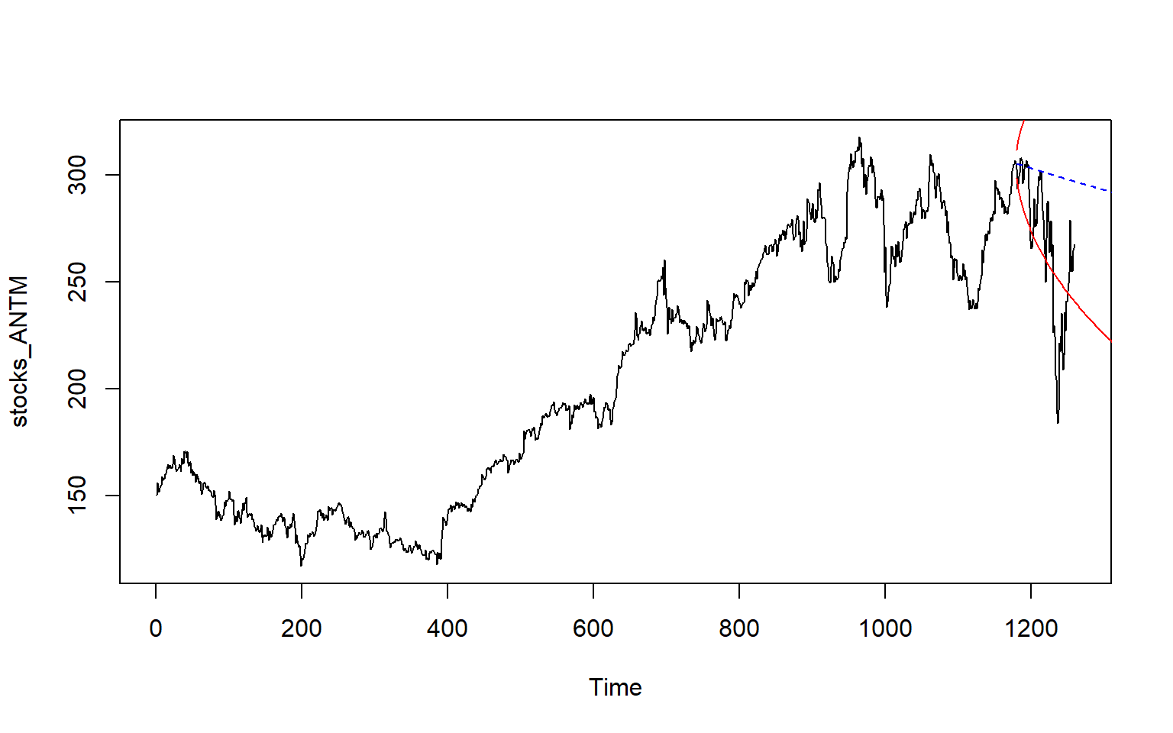

*# MA Moving Average Modege*

MA_old_forecasts <- **predict**(MA_ANTM_old, n.ahead = 300)**$**pred

MA_old_forecast_se <- **predict**(MA_ANTM_old, n.ahead = 300)**$**se

**plot.ts**(stocks_ANTM)

**points**(MA_old_forecasts, type = "l", col = 4,lty=2)

**points**(MA_old_forecasts **-** 2**\***MA_old_forecast_se, type = "l", col = 2, lty = 1)

**points**(MA_old_forecasts **+** 2**\***MA_old_forecast_se, type = "l", col = 2, lty = 1)

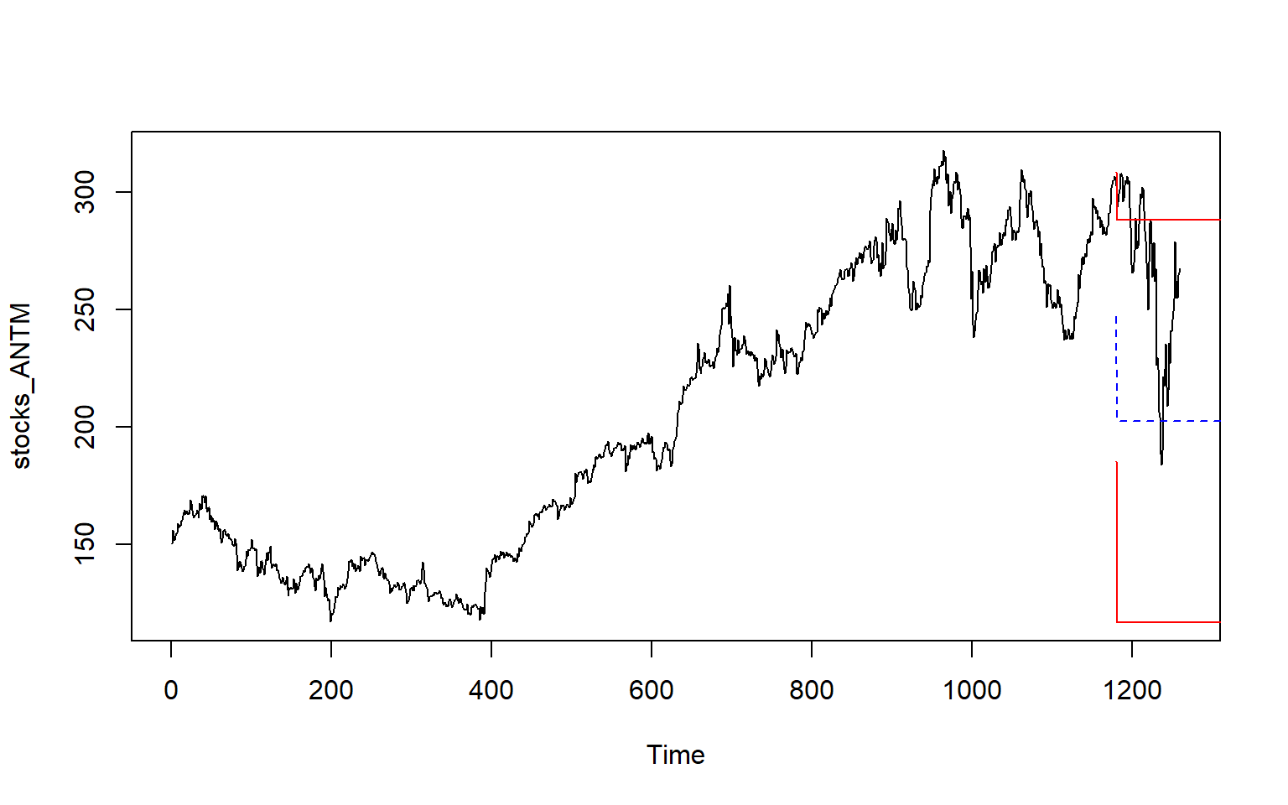

As we can very clearly see the from the figure in right:

* MA Model has predicted best in case of Year 2020 from the model which was fitted on data until Year Dec-2019.
* AR model prediction is way off from actual value, even though its close to negative range of the prediction.

## Check Model

If we compare the data and results from AR and MA Model , we noted that:

* MA model seems to be doing better with predication when we used data till Dec 2019.
* For instance from the figure in right we can see very clearly a sharp drop in price, due to COVID-19 Pandemic. Lets see how these two Model predicted if we go by full data:
* When we use full data set to predict the value for year 2020.
* AR Model does good with data set with random variation and model can predict better in comparison with MA model.

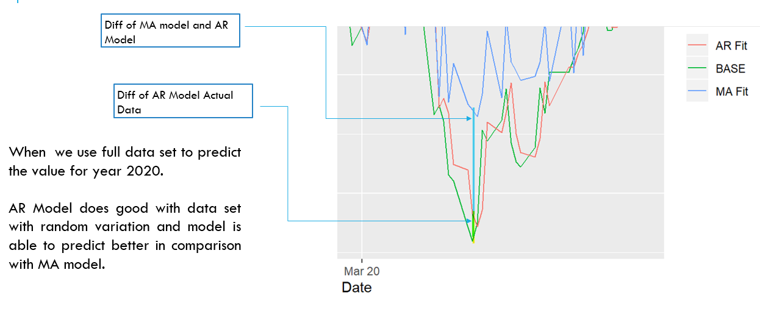

### Compare The Model:

Our Model comparison shows that AR(1) model is predicting the price correctly compare with MA model.

|  |  |  |  |  |
| --- | --- | --- | --- | --- |
| Data Group | Model | **df** | **AIC** | BIC |
| Ful Data | AR_ANTM | 3 | 7142.246 | 7157.66 |
| MA_ANTM | 3 | 12245.19 | 12260.6 |
| Till Jan- Apr 2020 | AR_ANTM_MY | 3 | 608.5171 | 615.6632 |
| MA_ANTM_MY | 3 | 707.9615 | 715.1076 |
| Til Dec 2019 | AR_ANTM_old | 3 | 6151.07 | 6166.287 |
| MA_ANTM_old | 3 | 11435.55 | 11450.77 |

# CONCLUSIONS

Based upon our underacting of this time series analysis we noted that:

* Different model can be used to better predict same set of time series
* AR model is would always perform better for few predictions if market is not stable
* MA model may give better predication when market is very unstable
* Training and testing in Time series data depends on portioning data by date, Random selection of such data may not be accurate choice to better check the efficiency of the model.

# APPENDIX:



<https://github.com/Rajwantmishra/DATA621_CR4/blob/master/Final/Final%20project.Rmd>

# THANK YOU